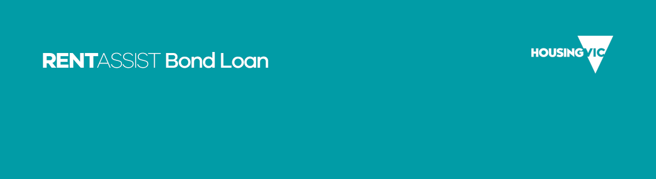

Applicant declaration and acknowledgement

About this form

Submitting this form
Complete this form and upload it with your completed online bond loan application.
More information about bond loans is available on Housing.Vic’s Bond loan page <https://www.housing.vic.gov.au/bond-loan>.

Your information
All information you give us is handled in line with the Health Records Act 2001 and the Privacy and Data Protection Act 2014.
Your information is collected to assess your eligibility for a bond loan and, if approved, provide a bond loan.
Your information is not used or disclosed for any other purpose without your consent unless there is a legal requirement to do so.
To learn more about how we protect your privacy and confidentiality, please see our privacy policy <https://dhhs.vic.gov.au/publications/privacy-policy> or email our Privacy Unit <privacy@dffh.vic.gov.au>.
You can access your information held by the department by speaking to a housing services officer at your local office or contacting the department's Freedom of Information Unit. Your housing services officer can tell you how to do this or see our Making a Freedom of Information request page <https://www.dffh.vic.gov.au/making-freedom-information-request>.

Declaration
Applicant details | Enter details
First name
Last name
Of (current address)
To the Department of Families, Fairness and Housing, 50 Lonsdale Street, Melbourne 3000:
I acknowledge that the bond money paid on my behalf through the estate agent or landlord to the Residential Tenancies Bond Authority is a loan advanced by the Director of Housing to me and any other applicant with whom I have applied.
I authorise the Department of Families, Fairness and Housing to issue a voucher payable to the Residential Tenancies Bond Authority, and undertake to provide this voucher to the estate agent or landlord named in my bond loan application.
I acknowledge that all applicants are jointly are severally liable for any outstanding bond loan amount when the tenancy ceases. This means that each applicant and all applicants together are liable to any part of the bond loan not refunded to the Director of Housing by the Residential Tenancies Bond Authority.
I understand that when a tenancy has ended, the Residential Tenancies Bond Authority will refund the bond loan directly to the Department of Families, Fairness and Housing, less any amount that the landlord has legally claimed.
On that basis, where the full bond loan amount is not returned automatically to the Department of Families, Fairness and Housing, I agree to repay, on request, to the Department of Families, Fairness and Housing any balance retained by a landlord when the tenancy ceased.
I declare that to the best of my knowledge, all the information in this application for a bond loan is true and correct.

Date
Full name
Signature of person making declaration (sign by hand)

To receive this publication in an accessible format email Housing Business Support <housingbusiness.support@dffh.vic.gov.au>.
Authorised and published by the Victorian Government, 1 Treasury Place, Melbourne.
ISBN 978-1-76069-772-3 (pdf/online/MS word)
© State of Victoria, Department of Families, Fairness and Housing, April 2022.
Available on Housing.vic’s Forms and Guides page <https://www.housing.vic.gov.au/about/forms-guides>.

