

Special accommodation requirements
Accessible version

Instructions
Use this form to request specific types of housing or to live in a specific area because of a medical condition, disability or due to a safety risk. Special accommodation requirements can be related to yourself or anyone who will live with you when you get housing.

 Filling in this form
Use blue or black pen. Write in CAPITAL letters. Mark boxes with a X

Submitting this form
Take or send this form to the Department of Health and Human Services office that is managing your application or submit this form along with your Register of Interest and/or Priority Access application/s.

Need help?
Need help or want this document in another format? Go to Housing.vic’s Social housing page <https://www.housing.vic.gov.au/social-housing> or contact your local Department of Health and Human Services office.

Office use only
Date received
Received by
Date registered
Service ID
Complete? (Yes or No)

Section A

Primary applicant's details
In this section, we ask for the details of the person who is the owner (primary applicant) of the Victorian Housing Register application.

Q1 Title

Title | Mark with X
Mr
Miss
Ms
Mrs
Dr
Prof
Other

Q2 First name
First name

Q3 Middle name
Middle name

Q4 Last name
Last name

Q5 Date of birth
Date of birth

Q6 Gender
Gender | Mark with X
Male
Female
Indeterminate
Intersex
Other

Q7 Application number
Application number

Q8 Telephone
Telephone

Q9 Email
Email

Section B

Your details
In this section, we ask for the details of the person who has the special accommodation requirements.

Q10 Title

Title | Mark with X
Mr
Miss
Ms
Mrs
Dr
Prof
Other

Q11 First name
First name

Q12 Middle name
Middle name

Q13 Last name
Last name

Q14 Date of birth
Date of birth

Q15 Gender
Gender | Mark with X
Male
Female
Indeterminate
Intersex
Other

Q16 Telephone
Telephone

Q17 Email
Email

Q18 Are you a participant of the National Disability Insurance Scheme (NDIS)?
If no, please skip to Question 20
Option | Mark with X
No
Yes

Q19 Please provide your NDIS reference number:
NIDS reference number

Q20 Please provide the contact details of your NDIS support provider:

Section C

Location needs
A location need is a need for housing in a specific area so that you can access ongoing specialist treatment, care, education or due to a safety risk.

Q21 Do you need to live in a specific area to access medical facilities or designated service provider because they are not available anywhere else?
Option | Mark with X
No
Yes

Q22 If yes, which areas, and why?
Which areas and why?

Q23 Do you receive ongoing regular support from family or friends or rostered care for a medical condition or disability?
Option | Mark with X
No
Yes

Q24 If yes, please provide details?
If yes, please provide details?

Q25 Do you have difficulty with accessing medical facilities, your designated service provider or receiving care from family or friends?
Option | Mark with X
No
Yes

Q26 If yes, please provide details?
If yes, please provide details

Q27 Do you need access to schools offering specialised education?
Option | Mark with X
No
Yes

Q28 If yes, which schools do you need to access?
Which schools do you need to access?

Q29 Do you need to exclude any specific locations?
For example, this might include areas where there is a risk of family or other violence, or where there is a negative impact on your wellbeing.
Option | Mark with X
No
Yes

Q30 If yes, which locations do you need to exclude and why?
Which locations do you need to exclude and why?

Property type needs
The type of housing needed because you:
- have limited mobility or a medical or mental health condition
- need minor modifications such as grabrails or lever taps
- need major modifications such as internal fire safety sprinkler or a bath hoist
- need full disability modifications
- need a wheelchair accessible property
  - need an extra bedroom because of a medical condition

Q31 What kind of property best suits your needs?
What kind of property best suits your needs? | Mark with an X
I can manage any property type
Up to one flight of external stairs/no internal stairs
Up to 1-4 entrance stairs/no internal stairs/no lift
1-4 entrance stairs/lift access/an occasional flight of stairs
Ground floor access/no external or internal stairs/ramp access/no lift

Q32 Select the following that best describes your required property type:
Type | Mark with an X
Medium-density: a dwelling in a multi-unit development of between two and five storeys
Low-density, attached: one of two or more dwellings, physically joined to other units by a common wall or roof
Low-density, detached: a single dwelling, not attached to another property in any way

Q33 Do you need changes to the property because of a medical condition or disability?
Option | Mark with X
No
Yes

Q34 If yes, tell us which:

Minor modifications

Minor modifications | Mark with X
Clothes dryer exhaust duct
Grabrails
Hand held shower set
Handrails
Hearing Aid support
Lever door handles
Lever taps
Lowered rails in wardrobes
Shower or bath seat
Wheelchair charging bay

Major modifications
Major modifications | Mark with X
Additional hard-wired smoke detectors
Accessible doors
Bath hoist
Bath tub required
Bathroom stepless shower
Bedroom hoist
Disabled toilet
Disability bath installed
Floor waste drains
Internal fire safety sprinkler system
Kitchen lowered benches
Laundry lowered benches
Lowered hand basin
Non-slip floor
Ramp access
Relocation of power outlets or light switches
Special security (entry)
Step in shower size
Wheelchair accessible car park

Full disability modifications
Mark with X
Full disability modifications
Wheelchair accessible dwelling

 Some changes, due to their nature, will need endorsement or detailed installation instructions or both from an occupational therapist before they can be installed.

Q35 Do you need an extra bedroom for any of the following reasons?
Reason | Mark with X
Medical condition
Medical equipment
Live in or rostered carer (full time)
Other

Other (please specify)

Q36 Do you need a medical heating/cooling system like an air conditioner?
Option | Mark with X
No
Yes

Section D

Declaration, acknowledgement and consent
I declare that all the information requested in this application for special accommodation requirements has been provided and is true and correct.
I acknowledge that I must advise the Department of Health and Human Services if my circumstances change and update the department with any details that are relevant to my Victorian Housing Register application.
I authorise the Director of Housing, or officers acting on behalf of the Director of Housing to confirm information concerning this application with people and organisations I have previously nominated, including if applicable, the treating health practitioner, designated service provider or professional that has completed Section E of this application.
WARNING: If you wilfully give information that is untrue in this application, you may be liable to penalties under Section 40 of the Housing Act 1983 (VIC).
Primary applicant’s full name
Primary applicant’s signature | [Please sign by hand]
Date

Information privacy
The Department of Health and Human Services is committed to protecting the privacy of your personal information. Personal information is information which directly or indirectly identifies a person. We need to collect and handle your personal information in order to be able to process your application. All the information you give us will be handled in accordance with the Privacy and Data Protection Act 2014 and the Health Records Act 2001.
If you are using other department programs we may share some of your information with them to help us coordinate better services for you. We will not use your information for any other purpose other than those listed on these forms, to provide services to you, or without your consent, unless the law requires us to do so.
You can access your information through the Freedom of Information Act 1982 or through the Privacy and Data Protection Act 2014. For information about Freedom of Information (FOI) requests, call 1300 475 170 or make your FOI access request online through the Office of the Victorian Information Commissioner website <https://ovic.vic.gov.au/freedom-of-information/for-the-public/make-your-request-online>.
For further information about privacy, call 1300 884 706 or email the Complaints and privacy unit <privacy@dhhs.vic.gov.au>

Section E

Professional details

 Stop
This section should only be completed by the health practitioner, designated service provider or other relevant professional (for example, the principal of a specialist school) that is relevant to the special accommodation requirements being requested.

Q37 Name of professional
Name of professional

Q38 What is your profession?
Profession | Mark with X
General practitioner |  | Other (please specify below)
Psychologist
Social Worker/Support worker
Psychiatrist
Occupational therapist
Specialist (please specify below)
NDIS Support Coordinator

Specialist – field (please specify)

Other (please specify)

Business address or stamp

Q39 Telephone
Telephone

Q40 Email address
Email
When completing this form, it is important to distinguish (wherever possible) between those accommodation requirements which are critical to the client’s wellbeing, as opposed to those which may be preferable or ideal.
For example, the client may be a patient at a local health service. Is it essential that the client remains in a specific location to continue to receive required treatment from this service or are there alternative services available elsewhere that can provide the same treatment?

Q41 What medical condition or disability does the applicant experience?

Medical condition or disability | Mark with X
Parkinson’s Disease
Heart Condition (severe)
Lymphoedema
Cerebral Palsy
Multiple Sclerosis
Fibromyalgia
Motor Neurone Disease
Emphysema (severe)
Quadriplegia
Epilepsy (uncontrolled)
Scleroderma
Cystic Fibrosis
Muscular Dystrophy
Cancer
Poliomyelitis or Post Poliomyelitis Syndrome
Renal failure
Chronic Obstructive Pulmonary Disease
Myasthenia Gravis
Systematic Lupus Erythematosus
Stroke
Chronic Fatigue Syndrome
Other

Other (please specify)

Q42 Describe the applicant’s medical condition or disability:
Describe the applicant’s medical condition or disability:
- How does it relate to their special accommodation requirements?
  - How is it essential for their health and wellbeing that they move from where they live now?

Declaration by professional
This section is only to be completed by the treating health practitioner, designated service provider or other relevant professional.
I declare that the person named in Section B of this application has the specific accommodation requirements as detailed in this form because of a medical condition or disability, or their safety is at risk.
Full name
Signature | [Please sign by hand]
Date

Language link
This publication is about housing. If you have difficulty reading English, you can get help with this publication. Please contact your local office or call Language Link on (03) 9280 0799 for an interpreter.
For other languages, an interpreter is available through your local office.
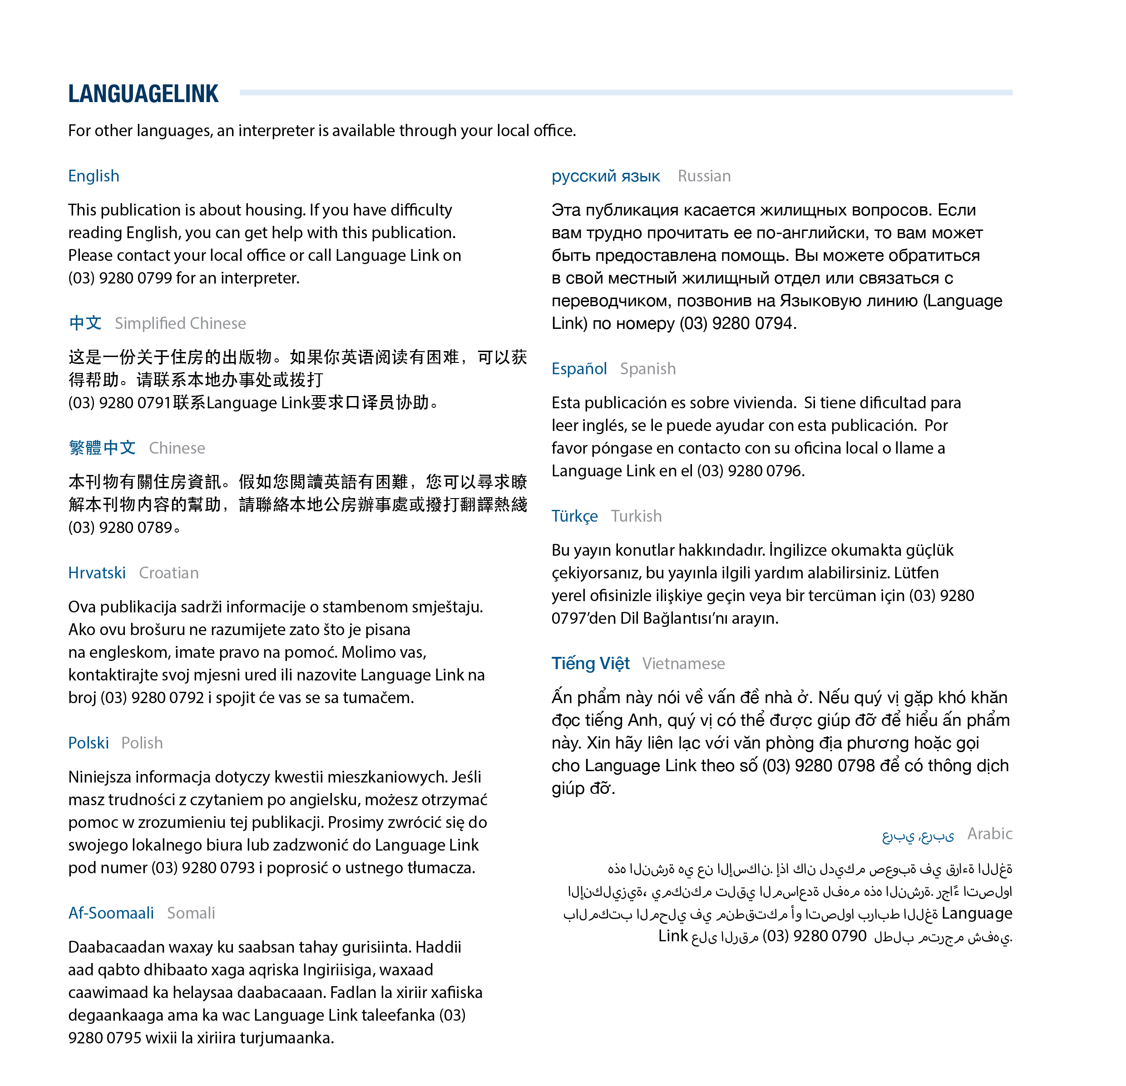
To receive this publication in an accessible format phone 1300 475 170, using the National Relay Service 13 36 77 if required or contact your local office <https://www.housing.vic.gov.au/contact-a-housing-office>.
Authorised and published by the Victorian Government, 1 Treasury Place, Melbourne.
© State of Victoria, Department of Health and Human Services, July 2019.
Available at Housing.vic’s Apply for social housing page <https://www.housing.vic.gov.au/apply-social-housing>
(1709042)

