

|  |
| --- |
| Victorian Public Housing Resident Survey |
| 2019 State Summary |

Contents

Background 2

Survey participants 3

What are our residents saying about housing? 4

Key theme 1: Stable and suitable housing 5

Key theme 2: Health and Lifestyle 6

Key theme 3: Safety and Security 7

Key theme 4: Culture and Community Engagement 8

Next steps 9

# Background

In Victoria, large scale surveys of public housing residents have not been common practice. The Department of Health and Human Services has developed a survey to deeply understand the lived experience of public housing residents. The views, opinions and perceptions of people living in public housing is key to the successful transformation of the department’s housing business, ultimately improving the department’s response to the diverse needs of residents.

The survey was conducted by a combination of computer assisted telephone interviews and face to face interviews using tablets between 31 October 2019 to 16 December 16, 2019. The department intends to regularly survey and engage residents in public housing on issues that affect them.

The survey aims to understand public housing residents’ views of five key areas:

1. Housing Services. 2. Health and life satisfaction. 3. Safety and security. 4. Social inclusion and community connection. 5. Financial and food security.

# Survey participants

A total of 1,847 surveys were conducted amongst residents in 15 public housing sites.

A map of the 15 public housing sites across Victoria. These include, Ballarat, Bendigo, Benalla, Wodonga, South Melbourne, Port Melbourne, Richmond, Fitzroy and Gippsland.A 30% sample rate was achieved for each site. 4% of residents are of Aboriginal and/or Torres Strait Islander origin. Top 5 preferred languages spoken are English, Vietnamese, Cantonese/Mandarin, Arabic and Hakka.

# What are our residents saying about housing?

65% of residents are satisfied with our tenancy service. 62% of residents are satisfied with the maintenance of outside common areas and grounds.

32% of all residents are dissatisfied with security of the car park. 79% of residents are satisfied with their property size. 82% of residents are satisfied with the number of bedrooms in their home.

73% of residents are satisfied with the privacy of their home. Security was one of the negative aspects about their home that was volunteered by many respondents when asked about what they disliked most about their house.

# Key theme 1: housing services



Respondents were most likely to mention **aspects of their location** when asked what they liked most about their home. The three housing attributes receiving the highest satisfaction scores (very satisfied and satisfied combined) were:

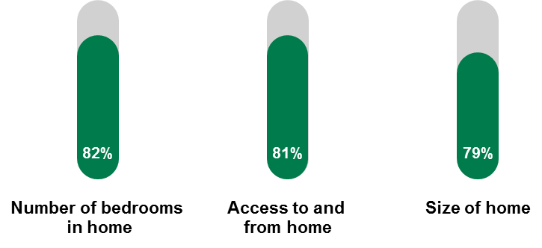



Respondents were most likely to mention **issues about neighbourly behaviour** when asked what they disliked most about their home. The three housing attributes with the highest dissatisfaction (very dissatisfied and dissatisfied) were:

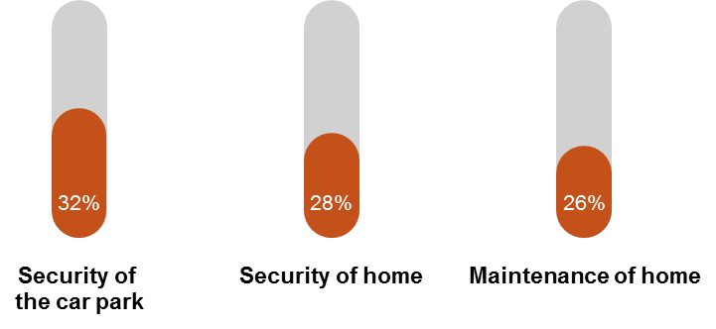

# Key theme 2: health and life satisfaction



In general, respondents have positive perceptions of their lifestyle and 73% are satisfied with their life as a whole. Visitation to health practitioners is relatively high:

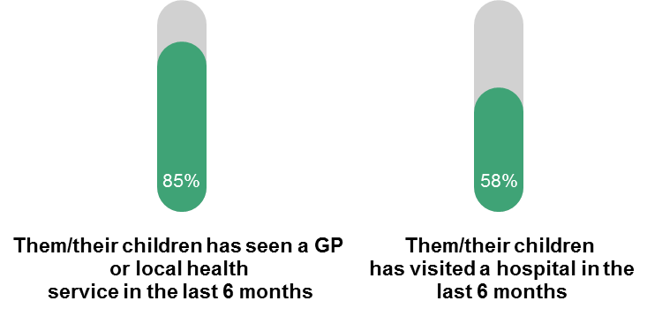



When compared to the general Victorian population[1] (20%), more public housing residents rate their health as fair or poor (58%).

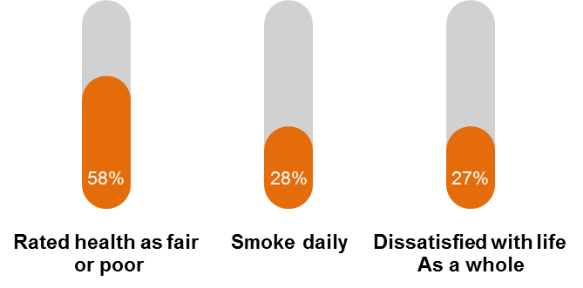

# Key theme 3: safety and security

Neutral face

Overall, security was one of the negative aspects about their home that was volunteered by many respondents when asked about what they disliked most about their house or their neighbourhood.

52% have witness/experienced theft or burglary. 47% Have witness/experience assault. 43% feel unsafe walking alone in their local area after dark. 58% witness/experience drugs and/or dealing regularly. 45% witness/experience verbal or physical threats.

# Key theme 4: Social inclusion and community connection



Overall, results for culture and community engagement are positive. A significant proportion of residents (83%) welcome diversity on the estate.

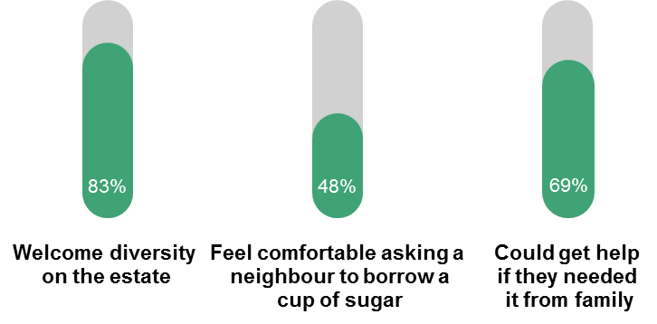

Neutral face

Neighbourhood/neighbours received mixed comments which were largely dependent on individual site locations.

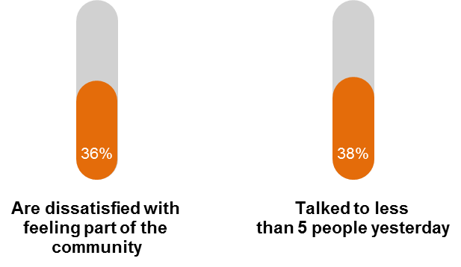

# Next steps

The Department of Health and Human Services is grateful to the many public housing residents who participated in this survey and expressed their views on our housing services, health and life satisfaction, safety and security, social inclusion and feelings of community connection.

* We will work continuously to improve our housing services and respond to the issues raised by residents
* The department will use the survey results to work at a local level to respond to local concerns about health and safety, and connection to the community
* We commit to regularly surveying public housing residents statewide and sharing the survey results with our community

For further information on the survey or to provide feedback please email [Social Housing Reform unit](http://shr@dhhs.vic.gov.au) <shr@dhhs.vic.gov.au>

To receive this document in another format phone [Social Housing Reform unit](http://shr@dhhs.vic.gov.au), <shr@dhhs.vic.gov.au>.

Authorised and published by the Victorian Government, 1 Treasury Place, Melbourne.

© State of Victoria, Australia, Department of Health and Human Services, November 2020.

Available at [Housing VIC, Getting Involved](https://www.housing.vic.gov.au/getting-involved) <<https://www.housing.vic.gov.au/getting-involved>>

1. According to the Victorian Population Health Survey