

**Public Housing Resident Survey 2019**

The Department of Health and Human Services developed a survey to better understand the views, opinions and perceptions of public housing residents. The findings from the survey will help the Department to respond to issues that matter most to residents and the community.

**A total of 1,847 surveys were completed by residents in 15 public housing sites**(face to face, over the phone and via smartphone between 31 October and 16 December 2019)

A map of Victoria that marks the 15 different public housing sites where residents participated in the survey.
 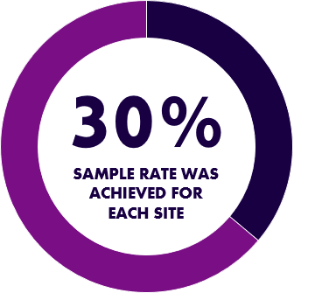

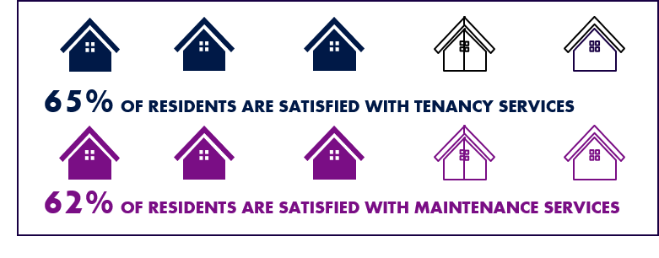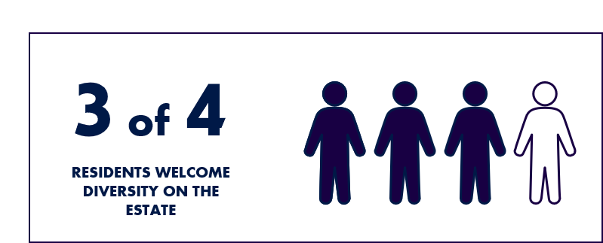

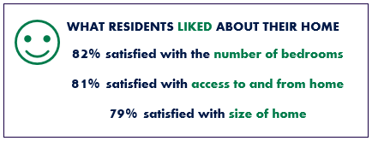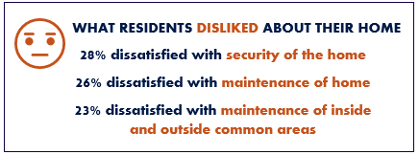

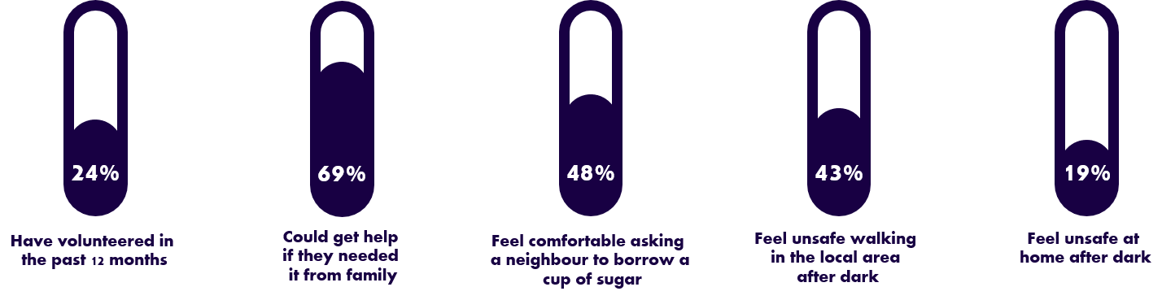

To receive this document in another format phone [Social Housing Reform unit](http://shr@dhhs.vic.gov.au), <shr@dhhs.vic.gov.au>.

Authorised and published by the Victorian Government, 1 Treasury Place, Melbourne.

© State of Victoria, Australia, Department of Health and Human Services, November 2020.

Available at [Housing VIC, Getting Involved](https://www.housing.vic.gov.au/getting-involved) <<https://www.housing.vic.gov.au/getting-involved>>