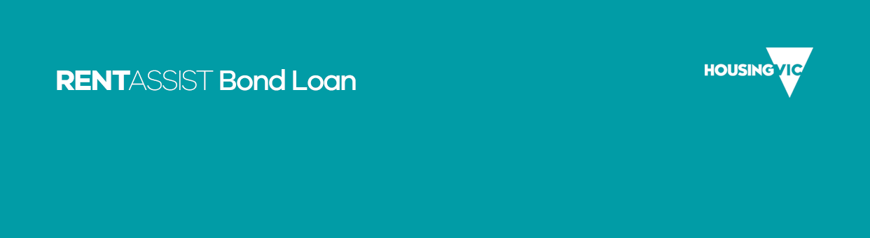

Private landlord release of information and agreement to tenancy

About this form
This form has been provided to you as you are a private landlord who is not using a real estate agent to manage your property.
As a private landlord you need to verify that the information on this form is correct. If any information is incorrect, please write over the incorrect information.
Once you have done this, please sign the form.
The Department of Health and Human Services will then make a decision about granting this bond loan.
More information about bond loans is available on Housing.vic’s Bond loan page <https://www.housing.vic.gov.au/bond-loan>.

Residential Tenancies Bond Authority registration number
The Residential Tenancies Bond Authority (RTBA) has an online facility for landlords that manage their own residential rental premises. Once registered, you will have access to the RTBA’s Electronic Transactions Facility, which allows you to lodge bonds, make repayment claims and carry out tenant transfers electronically.
To register as a Property Manager with the RTBA, please go to RTBA’s Property Manager registration page <https://rentalbonds.vic.gov.au/PropertyManager/Account/Register>
After your registration is complete, you will be given an RTBA registration number that you will need to quote on this and all future documents.

Your information
The Department of Health and Human Services is committed to protecting the privacy of your information.
To learn more about how we protect your privacy and confidentiality, please see our privacy policy <https://dhhs.vic.gov.au/publications/privacy-policy> or email our Privacy Unit <privacy@dhhs.vic.gov.au>.
Under the Freedom of Information Act 1982, you can also apply for access to your information held by the department. For more information, see our Making a Freedom of Information request page <https://dhhs.vic.gov.au/making-freedom-information-request>.

Rental property details
Detail | Response
Rental property address
Number of bedrooms
Type of property
Number of people on the lease
Lease start date
Lease end date
Total property bond amount
Total weekly rent amount
Please note that by completing this form the Director of Housing, or officers acting on behalf of the Director of Housing, will obtain information from a local council or online directory to confirm ownership of your rental property.
Please provide your local council name

Private landlord details
Detail | Response
Title
First name
Last name
Address
Phone number
Email address
ABN
Residential Tenancies Bond Authority registration number

Name of people applying for this bond loan
Person | Name
Person 1
Person 2 (if applicable)
Person 3 (if applicable)
Person 4 (if applicable)

Private landlord’s confirmation and agreement
Detail | Response
Full name
Signature
Date signed

To receive this publication in an accessible format email Housing Practice and Complex Support <housing.practicesupport@dhhs.vic.gov.au>.
ISBN 978-1-76069-774-7 (pdf/online/MS word)
Authorised and published by the Victorian Government, 1 Treasury Place, Melbourne.
© State of Victoria, Department of Health and Human Services, November 2018.
Available on Housing.vic’s Forms and Guides page <http://www.housing.vic.gov.au/about/forms-guides>

