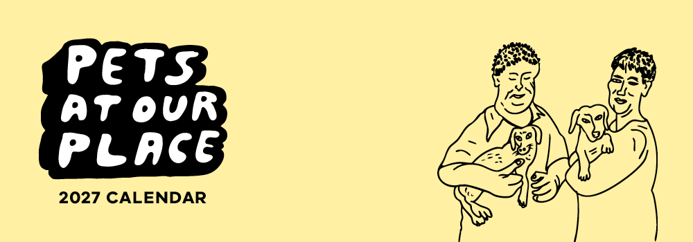

Pets At Our Place 2026-27 calendar competition entry form
If your entry is successful, the Department of Families, Fairness and Housing (DFFH) will ask you for consent to publish your photo, first name, local area and pet details.
If you need help to complete this form:
- email the Pets At Our Place team at petsplace@dffh.vic.gov.au or
- call either 03 8633 4357 or 03 8633 4362.

Entrant details
Information required | Your information
Name of entrant
Email address
Residential address
Contact number
Local area
Pet name
Pet breed/species

Type of housing
Please mark with an ‘X’ | Public housing |  | Community housing

Has the local housing office granted permission to have the pet at this residence?
Please mark with an ‘X’ | Yes |  | No
If no, please notify your DFFH local housing office if you are a public housing renter or your community housing provider if you are a community housing renter.
If you need help to contact your DFFH local housing office or community housing provider, please contact petsplace@dffh.vic.gov.au

Have you obtained a licence, or have you received council registration for your pet?
Every dog and cat 3 months of age and over must be registered with your local council. Some species of birds, mammals, and reptiles require a licence in Victoria.
Please mark with an ‘X’ | Yes |  | No |  | Not applicable
If no, we encourage you to contact your local council to register your pet. If you need help, please contact petsplace@dffh.vic.gov.au
Are you under 18 years of age?
Please mark with an ‘X’ | Yes |  | No

Tell us about your pet
It is important to capture the story of you and your pet. This will help the judging process, along with your pet photo. Please provide a few sentences.
You may wish to answer questions such as:
- What is your pet’s personality like?
- What do you and your pet most enjoy about living in public housing?
- What funny things does your pet do?
- How did your pet come into your life?
- What difference has your pet made in your life?

About your pet

Contact us to receive this form in another format. Please phone the Pets At Our Place team on either 03 8633 4357 or 03 8633 4362 or email petsplace@dffh.vic.gov.au
If you are d/Deaf, hard of hearing, or have a speech/communication difficulty please contact us through your preferred National Relay Service (NRS) call channel Then, provide the NRS with our phone number [03 8633 4357 or 03 8633 4362]. For more information, visit About the National Relay Service
Authorised and published by the Victorian Government, 1 Treasury Place, Melbourne. © State of Victoria, Australia, Department of Families, Fairness and Housing, April 2026.
Available at HOUSING VIC Pets At Our Place Calendar https://www.housing.vic.gov.au/pets-our-place-calendar

https://www.accesshub.gov.au/about-the-nrs/nrs-call-numbers-and-links
https://www.accesshub.gov.au/about-the-nrs

