Pets At Our Place 2026 calendar competition entry form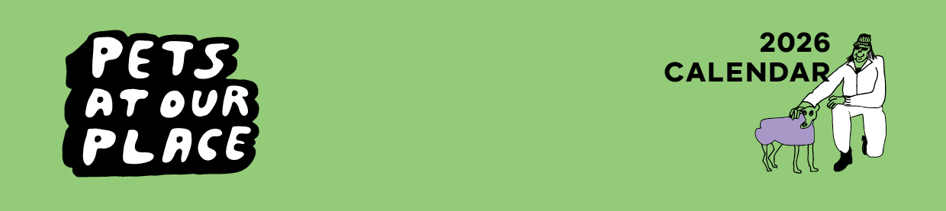

# Entrant details

|  |  |
| --- | --- |
| Name of entrant |  |
| Email address |  |
| Address |  |
| Contact number |  |
| Local area |  |
| Pet name |  |
| Pet breed/species |  |

If your entry is successful, the Department of Families, Fairness and Housing (DFFH) will ask you for consent to publish your photo, first name, local area and pet details.

If you need help to complete this form:

* email the Pets At Our Place team at [petsplace@dffh.vic.gov.au](mailto:petsplace@dffh.vic.gov.au) or
* call either 03 8633 4362 or 03 9830 9651.

## Type of housing

|  |  |  |  |  |
| --- | --- | --- | --- | --- |
| Please mark with an ‘x’ | Public housing |  | Community housing |  |

## Has the local housing office granted permission to have the pet at this residence?

|  |  |  |  |  |
| --- | --- | --- | --- | --- |
| Please mark with an ‘x’ | Yes |  | No |  |

If no, please notify your DFFH local housing office if you are a public housing renter or your community housing provider if you are a community housing renter.

If you need help to contact your DFFH local housing office or community housing provider, please contact [petsplace@dffh.vic.gov.au](mailto:petsplace@dffh.vic.gov.au)

## Have you obtained a licence, or have you received council registration for your pet?

Every dog and cat 3 months of age and over must be registered with your local council. Some species of birds, mammals, and reptiles require a licence in Victoria.

Please mark with an ‘x’

|  |  |  |  |  |  |
| --- | --- | --- | --- | --- | --- |
| Yes |  | No |  | Not applicable |  |

If no, we encourage you to contact your local council to register your pet. If you need help, please contact [[petsplace@dffh.vic.gov.au](mailto:petsplace@dffh.vic.gov.au)](mailto:petsplace@dffh.vic.gov.au)

## Are you under 18 years of age?

Please mark with an ‘x’

|  |  |  |  |
| --- | --- | --- | --- |
| Yes |  | No |  |

# Tell us about your pet

| It is important to capture the story of you and your pet, this will help the judging process along with your pet photo. Please provide a few sentences.  You may wish to answer questions such as:   1. ‘What is your pet’s personality like?’ 2. ‘What do you and your pet most enjoy about living in public or community housing?’ 3. ‘What funny things does get your pet do?’ 4. ‘How did your pet come into your life?’ |
| --- |

To receive this entry form in another format, phone the Pets At Our Place team on   
03 8633 4362 or 03 9830 9651 or email [petsplace@dffh.vic.gov.au](mailto:petsplace@dffh.vic.gov.au)

**If you need help with communication**

Contact us through the National Relay Service (NRS). For more information visit [National Relay Service](https://www.accesshub.gov.au/about-the-nrs) (https://www.accesshub.gov.au/about-the-nrs) to choose your preferred access point or call the NRS Helpdesk on 1800 555 660.

Authorised and published by the Victorian Government, 1 Treasury Place, Melbourne. © State of Victoria, Australia, Department of Families, Fairness and Housing, May 2025.

Available at [HOUSING VIC Pets At Our Place Calendar](https://www.housing.vic.gov.au/pets-our-place-calendar) https://www.housing.vic.gov.au/pets-our-place-calendar