
HousingVic Online Services (client self-service) and maintenance portal
Maintenance functionality enhancement
Privacy impact assessment report (Part 2)
October 2025
Version 1.0
OFFICIAL

Contents
Revision history 3
Glossary 3
Summary of assessment 3
Background 4
Description of the project 5
Scope of the assessment 6
Information elements 6
Personal information 8
Health information 9
Sensitive information 9
Privacy analysis 10
Privacy principles 13
Privacy risk mitigation 31
Definitions 36
Appendix 38
Appendix A 38
Appendix B 38
Appendix C 40
Appendix D 41
Appendix E 42
Appendix F - Records management review 56
Appendix G – Penetration testing 56

Revision history
Version | Amended section | Effective | Details
V0.1 | Draft | 16/06/2025 | Development of PIA for maintenance enhancements
V0.2 | Updated document based on feedback from legal | 30/09/2025
V1.0 | Final document ready for approval | 09/10/2025

Glossary
Abbreviation or term | Expansion or definition
the department | The Department of Families, Fairness and Housing
DMS | Document Management System
HiiPConnect | Digital tool enabling housing staff to perform housing functions offsite
HiiPRepairs | Department’s core housing maintenance management system
HVOS | HousingVic Online Services – online portal for housing clients
HCC | Housing Call Centre
HiiP | Housing Integrated Information Program – Department’s core housing system
LAO | Local Area Office
API | Application Programming Interface

Summary of assessment
HousingVic Online Services (HVOS) is being enhanced to enable housing clients (renters and residents) with a public housing tenancy to raise, view and track maintenance requests.
Data submitted via the maintenance request form will be stored in Microsoft Azure Databases located in Melbourne and Sydney, as well as in Outlook (if the requests were not created in HiiPRepairs).
At present, the department lacks the ability to purge this data, so it will be retained until a purging solution is implemented in FY25-26 as part of additional enhancements to the maintenance request form. The collected information will be shared with users of housing maintenance systems and third-party contractors to facilitate their support and response to housing maintenance requests.
Prior to submitting the form, renters and residents will be asked to consent to the data collection and its usage.
This Privacy Impact Assessment is an extension of the initial HVOS assessment which is available on the Housing website: https://www.housing.vic.gov.au/client-self-service-identity-verification-digital-mail-privacy-impact-assessment
Approver | Contact | Approval
Abhendra Singh  Principal Cyber Security Lead (cyber security components) | Abhendra.Singh@health.vic.gov.au | Signature:    Date: 18 Nov 25
Cathie Cerolini  A/Director, Service Delivery Support | Cathie.Cerolini@dffh.vic.gov.au | Signature:  Date: 16/10/2025
Liz Machado,  Project Director, Homes Victoria Business Systems | liz.machado@homes.vic.gov.au | Signature:    Date:16/10/2025
Thomas Kuster, Director Statewide Housing Operations | Thomas.kuster@dffh.vic.gov.au | Signature: Approved via email  Date: 3/11/2025
James Melville,  Managing Principal Solicitor, Legal Services Branch | james.meville@dffh.vic.gov.au | Signature:  Date: 17/11/2025

Background
The Department of Families, Fairness and Housing (the department) on behalf of the Director of Housing provides a range of housing services. It manages approximately 62,000 public housing tenancies, processes approximately 42,000 housing applications and 14,000 bond applications per year to access the private rental market and housing associations.
HousingVic Online Services (HVOS) allows housing clients to access and update their housing information securely using myGov.
This online platform currently allows housing clients to:
- Make a rental payment
- Request a statement
- Update their household income
- Update personal details
- Make changes to their household
- Respond to requests for documentation
- Receive digital mail
- Apply for a Victorian Housing Register Application
- Apply for a RentAssist bond loan
These features were assessed in a prior Privacy Impact Assessment which can be accessed on the Housing website: https://www.housing.vic.gov.au/client-self-service-identity-verification-digital-mail-privacy-impact-assessment

Description of the project
As part of the Homes Victoria Public Housing Maintenance Modernisation (PHMM) program, a project (P24195) is being undertaken to enhance HVOS capability to enable renters and residents to raise maintenance and for renters to view and track maintenance requests at a time that is convenient to them.
The Homes Victoria Public Housing Maintenance Modernisation (PHMM) program in partnership with Community Operations Practice Leadership (COPL), Department of Families, Fairness and Housing (DFFH) is undertaking substantial maintenance modernisation to:
- Enhance renter experience
- Boost contractor performance
- Improve process efficiencies
The previous Online maintenance request form (P23725) project implemented in August 2024 was the first phase of a permanent online portal solution (as an alternative channel to the phone line). This project is delivering the permanent online portal solution which will initially be accessed via HVOS (phase 2) followed by updating the existing online maintenance form and including a PII/PROV compliance solution (phase 3).
Upon submission, the maintenance requests will either be:
- integrated into the HiiPRepairs system into Defined state, with a notification of the job created and any files attached to the request sent via email (from Microsoft Outlook to the Genesys telephony system) to the Housing Call Centre for review and allocation to the contractor, or
- not integrated into the HiiPRepairs system, and the request details including any files will be captured into an email (from Microsoft Outlook to the Genesys telephony system) for the Housing Call Centre to assess whether to raise a job in HiiPRepairs or to contact the user for further clarification, or
- not integrated into the HiiPRepairs system due to a system error whereby a prompt will be displayed to the user for them to contact the Housing Call Centre for further assistance.

Scope of the assessment
The Privacy Impact Assessment (PIA) covers an analysis of an enhancement to HVOS which includes raising maintenance requests. It assesses the handling of data collected in the request form including what it is used for, which systems it is captured in and who has access to it.
Further, it identifies the interrelationship with the department’s housing Information Communication Technology (ICT) system HiiPRepairs and the security safeguards within that system from which maintenance information is stored.
As HVOS and potentially the current online maintenance request form are enhanced further over time, additional privacy impact assessments will be undertaken, when required, at a later date.
Roles in the assessment
This assessment has been prepared by the Homes Victoria Public Housing Maintenance Modernisation program and Community Operations and Practice Leadership and Information and Digital Solutions with input from DFFH Privacy Unit.
The Director, Service Delivery Support and Project Director, Homes Vic Business Systems are the joint business and data information owners.

Information Security Team
An Information Security Classification was completed for the program which includes enhancements to HVOS and is attached at Appendix A.

Information elements
There are four linked locations in which information is held to support HVOS:
- myGov - myGov (independent of the department) stores sufficient information to authenticate the user (a unique myGov user id, password, and contact mechanism for two-factor authentication). Depending on the user’s preference and other activities, myGov may store limited additional user information. For example, if the user has connected their myGov account with the ATO, myGov may store core user information including name and date of birth.
- HiiP system - is the core housing IT system used by the department to deliver housing services that stores all client information relevant to housing assistance clients are seeking from the department. HiiP is the core housing IT system used by department. The system has three primary registers: client, external party and property register, and related functionality to manage the delivery of bond loans, housing applications and tenancies.
- HiiPRepairs system – is the housing IT system that stores information about the departments assets including property addresses, property attributes, occupancy status, renter contact information, maintenance job history, contractor details and invoicing details.
- HousingVic Online Services- HousingVic Online Services (HVOS) accesses the department client information stored in HiiP and maintenance job information in HiiPRepairs. HousingVic Online Services is the host application that enables clients seeking housing assistance to link this application from within myGov’s portal into self-serve to access online services for housing assistance. HousingVic Online Services presents primary and secondary questionnaire to the client for the purpose of identifying and matching the client’s record in HiiP to enable access to their information and self-serve.
- Maintenance portal – a web application accessed via HVOS enabling renters to raise maintenance requests.
- HiiP integration layer - Data synchronisation between HiiP and HiiP integration layer which enables the storing of client information in the integration layer close to real time. The integration layer is where limited information about all the clients and their housing service is stored, once it is retrieved from the source system HiiP.
- Document Management System (DMS) – DMS is the module of HiiP and HiiPRepairs which stores and provides access to documents. It associates each document to a primary entity (e.g. a tenancy, client, housing application). It is designed to facilitate compliance with the Department's records-keeping obligations.
- Application Programming Interface (API) – Interface between HVOS, maintenance portal and HiiPRepairs.

At a more detailed level
- myGov
This Commonwealth online service provides access to and hosts a range of Government and related services to Citizens including Centrelink, Medicare, Australian Taxation Office and HousingVic Online Services.
myGov is operated by Services Australia and has its own governance, security and privacy arrangements - https://my.gov.au/mygov/content/html/security.html. The department client information, information related to client services and the digital mail attachments are not stored in or transferred to myGov, or platforms hosted and supported by Services Australia.
When a citizen links to HousingVic Online Services, myGov records this in its database in order to create that link.
When a client opts in for Housing Digital Mail, HiiP triggers delivery of a digital mail message to the client, accessible via the myGov Inbox service. myGov stores the message content of digital mail however does not store attachment content.
When any information on HousingVic Online Services is updated, other than enabling or disabling digital mail, this information is not passed to myGov.
- HiiP system
HiiP is the core housing IT system used by the department to deliver housing services. The system has three primary registers: client, external party and property register, and related functionality to manage the delivery of bond loans, housing applications and tenancies.
The system is secured within multiple firewalls and access to information is governed by user provisioning based on functional role. The system is not directly accessible by clients.
All department housing client information, information related to client services and the digital mail attachments are stored in HiiP (subject to the data synchronisation and storage in the HiiP integration layer discussed above).
- HiiPRepairs system
HiiPRepairs is the housing IT system that stores information about the departments assets. Third party contractors interact with HiiPRepairs by receiving job requests, updating job statuses, sending memos and invoices for completed works to the department.
The system is secured within multiple firewalls and access to information is governed by user provisioning based on functional roles. The system is not directly accessible by clients.
- HousingVic Online Services
HousingVic Online Services is the host application that enables clients seeking housing assistance to link this application from within myGov’s portal, in order to self-serve to access online services for housing assistance.
HousingVic Online Services presents primary and secondary questions to the client for the purpose of matching the client’s record in HiiP, the secondary questions include more detailed service specific questions that when matched, enables the client to opt in for digital mail services and view and update their information.
- Maintenance portal
Once the user accepts the privacy and consent in HVOS, the user is redirected to the Maintenance Portal, and HVOS passes the tenancy service ID during this redirection. Maintenance Portal is a subdomain of HousingVic Online Services; hence, it can share the authenticated myGov cookie that HVOS uses, and while it's redirected, if the cookie is still active, it gets authenticated. Once the authentication is successful, the Maintenance Portal calls the Client API to get the required client details.
- HiiP integration layer
The integration layer is where limited information about all the clients and their housing service is stored, once it is retrieved from the source system HiiP. The information is securely stored within the Azure cloud solution and provides near real time synchronisation of information between HiiP and rendering this information on HVOS. The integration layer is not directly accessible other than through its backend integration with HiiP.
- APIs
APIs (Application Programming Interfaces) are structured channels through which computer systems communicate.

Personal information
The project will collect the following personal information (or retrieve via HVOS), store it in the maintenance portal, and pass it to HiiPRepairs via an API:
- First name and Last name of renter/s
- Phone number
- Email address
- UPRN (unique property identifier)
- Photographs and videos of maintenance issue
This personal information will be used solely for the purpose of identifying the repair request – it will NOT be used to update the previously collected master record of this information in the Department’s housing systems (HiiP and HiiPRepairs).
The capture of other personal information has been assessed in a prior Privacy Impact Assessment which can be accessed on the Housing website: https://www.housing.vic.gov.au/client-self-service-identity-verification-digital-mail-privacy-impact-assessment

Health information
Health information is gathered and stored in HiiP where it directly impacts a client, their household and access to service including their property and locational needs.
Where a client for example has a mental health issue, this is not relevant unless they are applying for access to housing on the basis that they meet the criteria of Supported Housing – mental health category of the Victorian Housing Register.
This project does not seek the collection of health information. If sensitive information is disclosed in the course of describing the maintenance issue or via a photo/video, then the health information will be dealt with in accordance with the Health Records Act 2001 and the Health Privacy Principles (HPPs).

Sensitive information
This project does not seek the collection of sensitive information. If sensitive information is disclosed while describing the maintenance issue or via a photo/video, then the health information will be dealt with in accordance with the Health Records Act 2001 and the Health Privacy Principles (IPP).
Type of sensitive information | Details
Racial or ethnic origin | Not collected
Political opinions | Not collected
Membership of a political association | Not collected
Religious beliefs or affiliations | Not collected
Philosophical beliefs | Not collected
Membership of a professional or trade association | Not collected
Membership of a trade union | Not collected
Sexual preferences or practices | Not collected
Criminal record | Not collected
Note: Photographs taken by the renter or resident of their maintenance issues may inadvertently include any of the above types of sensitive information. DFFH staff will have the ability to delete content from a job including photos/media from a request if deemed irrelevant or inappropriate however as staff are not required to ‘vet’ the requests there may be times when information entered on a request is sent to the Head Contractor. Renters are made aware of this information sharing via a layered collection notice approach set out under the “Notice” section below.

Privacy analysis
Figure 1 Maintenance Request Form Information Flow
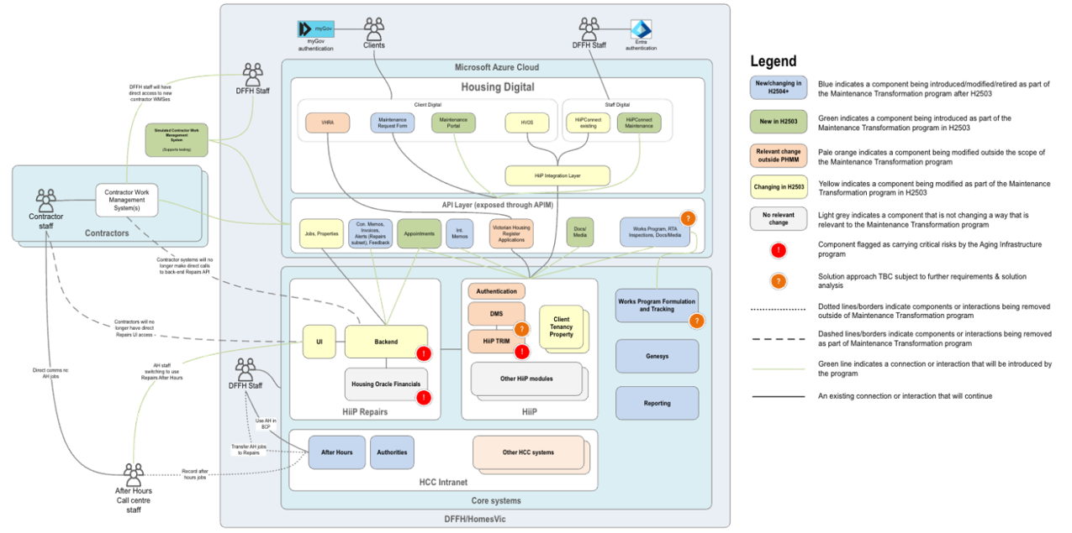
Figure 2 Information flow – identity verification, digital mail, access to my housing services information and making an online payment (assessed through previous PIA)
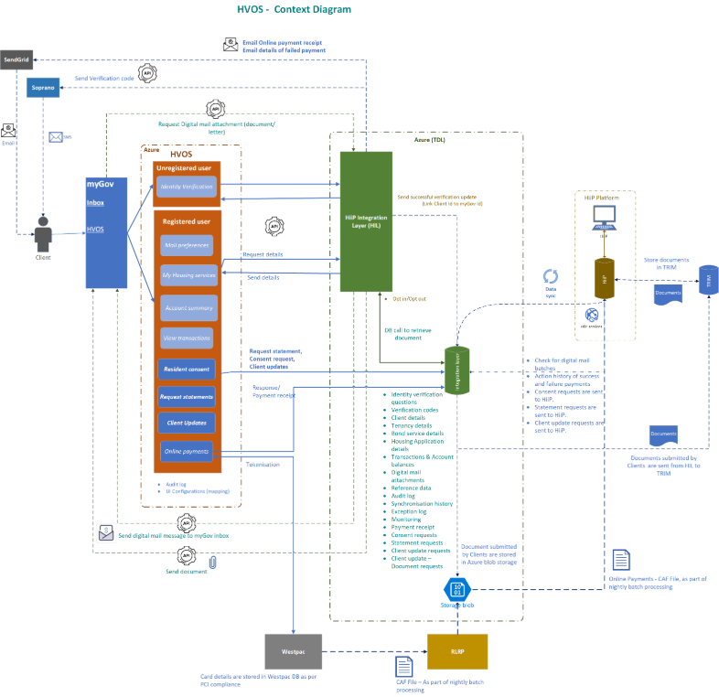
Figure 3 Information flow –updating personal, contact and Centrelink Confirmation eServices information (assessed through previous PIA)

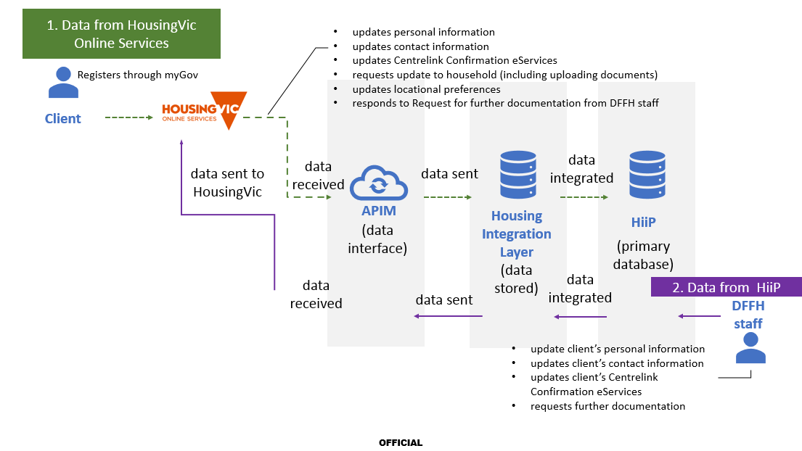

Privacy principles
Questions – what is the risk? | Further information | Yes / No | Detailed response
Collection: Is all the information collected necessary for the project? | IPP 1 and HPP 1  Privacy team | Yes | The details captured here are in addition to the details captured in the previous Privacy Impact Assessment: https://www.housing.vic.gov.au/client-self-service-identity-verification-digital-mail-privacy-impact-assessment  Information collected through HousingVic online services is required to match a client against their HiiP record to establish their identity and thereby access online services (including digital mail and housing services information).  This registration request and enabling access is also recorded in fields in HiiP which is necessary for the department to deliver the online services.  The Maintenance portal is being implemented as an additional service to HVOS users to improve the maintenance experience and provide more efficiency for departmental staff through automation of job orders and associated files directly into the Repairs system.  When accessing the Maintenance portal, the household member’s name, property UPRN and contact details are passed from HVOS which is necessary for the department to identify who is raising the request and which property requires maintenance.  Details about the maintenance issue are also captured, including photo evidence, to assist in the accurate identification of the problem requiring repair. Upon submission, this information is either:  - integrated into the HiiPRepairs system into Defined state, with a notification of the job created sent via email (from Microsoft Outlook to the Genesys telephony system) to the Housing Call Centre for review and allocation to the contractor, or  - not integrated into the HiiPRepairs system, and the request details will be captured into an email (from Microsoft Outlook to the Genesys telephony system) for the Housing Call Centre to assess whether to raise a job in HiiPRepairs or to contact the user for further clarification, or  - not integrated into the HiiPRepairs system due to a system error whereby a prompt will be displayed to the user for them to contact the Housing Call Centre for further assistance.  In addition, a confirmation is displayed on screen with a reference number (ie JobID if integrated into HiiPRepairs, request ID if not created) and a notification is generated to the renter/s via email to also confirm successful submission of their request.  There may be occasions when other information, not required is disclosed. This is only when renter includes this information and is not asked by HousingVic. There is also a disclaimer noted below in the ‘Notice’ section.
Notice: Have all reasonable steps been taken to inform the individual that their information is being collected and why, by whom, how they can access, to whom it will be disclosed? | IPP 1 and HPP 1  Fact sheet on developing a collection notice <https://dhhsvicgovau.sharepoint.com/sites/health/SitePages/Privacy.aspx#privacy-related-resources-on-the-intranet>  Privacy team | Yes | When an applicant from the Victorian Housing Register is made an offer of public housing, they are sent an offer letter which contains a Privacy Collection Notice section regarding data privacy and the purposes for which data collected once housed may reasonably be used for: Refer to the template in Appendix B.  In the Maintenance portal, there will be two layers of collection notice (see Appendix E for screenshots):  1) The following statement will be displayed on screen before a renter begins raising the request:  Your privacy is important  The information collected in this maintenance request will be stored securely and only used by the department and the third-party contractor to identify the maintenance issue, contact you to arrange access to repair the issue, and follow up on any feedback provided and assist us to further improve our services.  For more information about information collection details  Please ensure you do not include personal or health information in any free text fields unless you feel it is necessary for your request, as it will be provided to the department and may be shared with the third-party contractor. Please also be respectful in the language you use or in the information you provide.  The following statement will be displayed on screen before a resident begins raising the request:  Your privacy is important  The information collected in this maintenance request will be stored securely and used by the department and the third-party contractor to identify maintenance issues. The details of the maintenance request you raise will be sent to the renter/s in a confirmation email and available for the renter/s to view through their HousingVic Online Services account.  For more information about collection details https://www.housing.vic.gov.au/repairs  Please ensure you do not include personal or health information in any free text fields unless you feel it is necessary for this request, as it will be provided to the department and may be shared with the third-party contractor. Please also be respectful in the language you use or in the information you provide.  2) When the optional question is asked about adding an alternative contact number, the following message is displayed to the renter:  Do you want to add an alternative contact number?  This will not update your account details. These are alternative contact details only for this maintenance request.  If you have nominated someone to act for you, or provided personal information of another individual, please also direct them to Information collection details  When the optional question is asked about adding an alternative contact number, the following message is displayed to the resident:  Alternative contact details for this maintenance request  If you are a household member (but not the renter of the property) and are raising this maintenance request for the property you live in, please provide your phone number (mobile or landline) in the below field. You might be contacted for further information about this request. The number you provide will only be used for this issue and not saved on the renter's account details.  3) A link will be provided to the Housing website (Arranging maintenance and repairs | Housing.vic.gov.au) where a more detailed information collection notice is described at Appendix C.  4) Additionally, the standard departmental footer will have a link to the privacy statement on the Housing website: Privacy | Housing.vic.gov.au
Direct collection: Is all information being collected directly from the individual? | IPP 1 and HPP 1  Privacy team | Yes | The Maintenance portal collects information indirectly via HousingVic Online Services, an existing authenticated portal for housing clients that is accessed via myGov. They can currently view information about their housing application, bond loan application or tenancy, make payments and update certain information.  A link from HVOS to the Maintenance portal is a new feature. When they click on the link their Tenancy Service ID is passed to the Maintenance portal and the Maintenance Portal then calls the Client API to retrieve the client details. The information about the maintenance issue/s which includes free text fields and ability to upload photos/videos will be collected directly from the individual.  All information collected directly and indirectly will be passed via API’s to DMS (media files only) and HiiPRepairs, if the job is integrated, so the department can ensure a correct property match into the HiiPRepairs system.  If the job is not integrated into Repairs, the information on the request will be placed in an email to Microsoft Outlook and Genesys for the HCC to action.
Identifiers: Will this project assign a unique identifier or use a unique identifier of another organisation? | IPP 7 and HPP 7  Privacy team | No | As part of the current maintenance process, when a job is created directly in HiiPRepairs a unique identifier is auto generated by the system against the work order so it can be tracked throughout the different stages as it progresses.  The unique identifier is attached to the job (unique job ID), rather than the individual, so although the project will utilise identifiers, they are not “unique identifiers” as defined in the Privacy and Data Protection Act 2014.  The details from the Maintenance portal will integrate, in most cases, into HiiPRepairs, a unique Job ID will be generated and provided to the renter/s. It will also be sent via email to the HCC’s outlook and Genesys system, so they are made aware a job has been created that requires triaging i.e. the job needs to be created in HiiPRepairs or requires referral to another team within DFFH ie. lift issues, graffiti etc.  If the system does not create the job in Repairs, a Reference number is auto generated (as per current behaviour on the Online maintenance form) and provided to the renter in a confirmation message on the screen and via email to the renter/s (see Appendix D).
Anonymity: Can individuals remain anonymous for the purpose of the project? | IPP 8 and HPP 8  Privacy team | No | The renter’s personal details, including their first name and surname, property PIN, alternative phone number (if provided) and contact details are collected in the Maintenance portal.  Without this information, there would be a limitation for the HCC and LAO staff to follow up on requests and for the contractor to execute the requests. As a result, anonymity would render the raise maintenance request functionality in HVOS ineffective.
Sensitive information: Will this project collect sensitive information? | IPP 10  Privacy team | No | The Maintenance portal does not seek sensitive information. If sensitive information is inadvertently disclosed by the renter or resident, for example, in a photograph or video, it will be dealt with in accordance with the IPPs and Privacy and Data Protection Act 2014. The information collection notice provides information about the purpose of the information provided. There is also a disclaimer to discourage extra information which is noted in the ‘Notice’ section above.
Data security: Are reasonable steps being taken to protect the information collected from misuse, loss, and unauthorised access, modification or disclosure? | IPP 4 and HPP 4  Projects MUST engage the BTIM Information Security team to arrange assessment/s | Yes | The Maintenance portal is built in the current departmental DSPX framework for external-facing web applications.  The Maintenance portal is accessed through HVOS. If the renter clicks the Report maintenance button in HVOS they enter the Maintenance portal (this appears seamless to the client).  The submitted request data is stored in the department’s Azure Cloud Service platform. The department's Azure platform is monitored through Microsoft Defender for Cloud Security, while security events are tracked via the department's instance of Microsoft Sentinel, operated by the Fujitsu SOC service team. The security regulatory compliance of the Azure configuration is assessed against CIS and ISM controls. Security certifications applied to Azure Cloud Service include ISO/IEC 27001, SOC 1, SOC 2, Australian Government IRAP assessment at PROTECTED control and CIS benchmarks. These certifications ensure compliance with industry standards and enhance the security posture of the service.  All submitted requests are sent to departmental staff via Microsoft Outlook email to Genesys PureCloud which has been identified as the suitable telephony platform for a range of areas within the Department, including Housing, Child Protection and Emergency Response functions. It has undergone appropriate risk assessment processes with IT during the procurement phase.  Requests will also pass through HiiPRepairs API’s enabling a work order to be created in HiiPRepairs.  The Cyber Security Unit has reviewed the Information Security Classification for the online maintenance request form, and the classification is OFFICIAL: Protected (Appendix A).  A penetration test was performed on the new maintenance portal, administration portal (to manage settings) and related Repairs API on 23 September 2025 by Cyber Security. See attached report in Appendix G.  HiiP and HiiP Repairs are hosted in a Fujitsu-operated data centre in Noble Park (primary site) and a Next DC-operated data centre in Port Melbourne (secondary site), secured by firewalls and network security zoning. The systems are managed through Fujitsu Security Operations Centre. The security assessment completed for Azure and HiiP environment by BTIM Cyber Security team with low risks.
Use and disclosure: Will the information only be used or disclosed for the primary purpose identified? | IPP 2 and HPP 2  Privacy team | Yes | The information collected through the Maintenance portal will only be used for the primary purpose of the collection, as detailed above.  Personal information will be disclosed to the Housing Call Centre:  - via HiiPRepairs to review and allocate the job to the Head Contractor, or  - or via the email sent from Microsoft Outlook to Genesys that would contain all the details of the job including photos which would require triage by the Housing Call Centre resulting in the details being captured in HiiPRepairs and allocated to a contractor, referring the request to another team within DFFH who manages the maintenance or advising the user that it is not responsive maintenance, or  - via the departments reporting tool (ie Power BI, Housing Toolbox).  The Responsive Maintenance Team within Asset Management will receive de-identified aggregate data from HiiPRepairs for a secondary purpose of managing the contract requirements and performance including the review and reporting of each contractor’s job completion rates under KPI 2, 3 and 4 under the Property Maintenance Services Contracts. This information is provided through to Homes Victoria Executive Leadership each quarter to advise of contractor performance.  This aggregated information is also located within the Housing Reporting Toolbox and the Maintenance Jobs Performance Dashboard used by the Responsive Maintenance Team and Performance Improvement Team within Homes Victoria as well as Housing Services Managers to review contractor performance.
Information sharing: Will the information be shared with other agencies for service delivery, data matching or analytics? | IPP 2 and HPP 2  Privacy team | Yes | The Department will only share the personal information with a third-party Head Contractor or other area of the department to enable the maintenance requests to be actioned.  DFFH staff will have the ability to delete content from a job including photos/media from a request if deemed irrelevant or inappropriate however as staff are not required to ‘vet’ the requests there may be times when information entered on a request is sent directly to the Head Contractor.  Renters are made aware of this information sharing via a layered collection notice approach set out under the “Notice” section above.  When a renter or resident raises a maintenance request via HVOS, the following statement shows up, which then links to a longer form collection notice.  Information collection: Your privacy is important. The information collected in this request will be stored securely and only be used by the department and third-party contractor to identify the maintenance issue, contact you to arrange access to repair the issue and follow up any feedback provided and assist us to further improve our services. See link for further detail on data collection.  Please ensure you do not include personal or health information in any free text fields unless you feel it is necessary for your request, as it will be provided to the Department and may be shared with the third-party contractor. Please also be respectful in the language you use or information you provide.
Transborder data flows: Will the project transfer the information to an organisation or person outside of Victoria? | IPP 9 and HPP 9  Projects MUST engage the BTIM Information Security team to arrange an assessment | Yes | The Maintenance portal is hosted on the department’s platform across the Microsoft Azure Data Centres for the Australia South-East and East regions. The submitted repair request as an output transfers the captured data to Genesys PureCloud which is hosted on AWS Data Centre in Sydney and into HiiPRepairs as a job at Defined status ready for Housing Call Centre review.  Genesys PureCloud has been identified as the suitable telephony platform for a range of areas within the Department, including Housing, Child Protection and Emergency Response functions. It has undergone appropriate risk assessment processes with IT during the procurement phase.  HiiPRepairs is the department’s core system for managing maintenance for Homes Victoria properties. It is hosted in Melbourne.  Housing Call Centre staff (based in Melbourne) are retrieving the submitted request information either from HiiPRepairs directly, Microsoft Outlook or from Genesys PureCloud, where the details are entered into HiiPRepairs if the request is eligible for repair. The job created in HiiPRepairs is then passed on to a Head Contractor who actions the request. A confirmation email is sent to the renter/s of the property.  HVOS transmits data to the maintenance portal using SSL Encryption. No data is transmitted outside of victoria as HVOS and the maintenance portal are both hosted in Melbourne.  The Cyber Security Unit have reviewed the Information Security Classification, and as the classification result is OFFICIAL: Protected and further noting that this is a cross-functional form.
Data quality: Are reasonable steps being taken to ensure that the information collected, used or disclosed will be accurate, complete and up to date? | IPP 3 and HPP 3  Privacy team  Information and Data Management | Yes | Property and renter related information is proactively managed by the department in fulfilling its obligations to comply with Residential Tenancies Act.  However, there is a reliance on renters maintaining their contact details when communicating with the department. On occasion, telephone numbers, email addresses and postal addresses may therefore be out of date.  There are reasonable steps that are taken as part of this project to ensure that the information the form has collected, stored, modified, and transmitted for the renter to submit accurate, complete, and up-to-date data.  The HVOS Homepage has been updated to bring the opportunity for renter’s to update their contact details for their account to the forefront and an additional opportunity is provided when the renter wants to raise a maintenance request. Refer to Appendix E for screenshots.  There is the possibility of human error due to manual data entry when submitting the form. To mitigate this, as per current process with the Online maintenance form, renters are able to contact the LAO or HCC to discuss and have the opportunity to amend their data/information if they believe they have submitted wrong/inaccurate data.  1) As a further human error mitigation strategy, the Maintenance portal includes an automated message before a renter submits the request with the prompt:  By selecting the Submit request button, the issues you have raised will be submitted. To go back and review any issue, please select Cancel  2) Upon submission of the maintenance request, the renter or resident receives a confirmation on screen with a Job ID or reference number:  Thank you. We have received your maintenance request and are working to get it fixed for you. Maintenance request summary, <Reference no: XXX, type of repairs and locations>. One of our services officers will be in contact with you if further information is required. You may also be contacted by a contractor to arrange a time to attend. If your request is assessed as urgent, the contractor will make arrangements to attend as soon as possible.  3) Following submission of the maintenance request, the renter/s receive a confirmation email with the Job ID/reference number and can also view and track the job in HVOS.
Access and correction: Are there any restrictions that would prevent individuals from accessing or correcting their information? | IPP 6  Freedom of Information team  Privacy policy | No | There are no restrictions to access and correction. Renters can request access to the information (or request to correct the information) by contacting the Housing Call Centre or requesting access through Freedom of Information. The Freedom of Information Act 1982 (Vic) is the primary mechanism for access to and correction of information in documents held by Victorian government agencies, clients are entitled to make a FOI request which is supported by DFFH’s Freedom of Information Unit.  Renters are made aware of their ability to access and correct their information in the long form collection notice which states:  You are able to request access to this information, or request that your information be corrected through making contact with your local housing office. You can also request access through contacting Freedom of Information by email foi@dffh.vic.gov.au or phone (03) 9096 8449 or 1300 475 170.
Destruction: Will reasonable steps be taken to destroy or de-identify the information if it is no longer needed? (note this does not apply to a health service provider) | IPP 4  Public Records Act 1973  Records management team | No | With requests being submitted through HiiPConnect, similarly to the existing online maintenance form, the data and photos/videos collected in the form are stored in a database, Azure, and for the request that cannot be created in HiiPRepairs, in Microsoft Outlook. If the request is integrated into HiiPRepairs the photos/videos will be stored in DMS and against the job details in HiiPRepairs. The data remains within the system indefinitely to demonstrate a history of the works and asset management carried out against each property.  At present, the department does not have a way to completely remove the data from its systems.  After this project is implemented, this will continue to be the case.  For the requests that do pass the property address match and are passed into the HiiPRepairs database, the data remains within the system indefinitely to demonstrate a history of the works and asset management carried out against each property.  It is proposed that the current process continues whilst the project team continue to work towards a new automated PROV/PII solution by December 2025.  Refer to outcome of Records management review (Appendix F).
Re-identification: Will the project involve de-identified information that may be re-identified through the linking of data or other information? | Privacy team | Yes | The requests submitted via HVOS are integrated or manually entered into HiiPRepairs.  A departmental report is generated with identifiable data for the purposes of the HCC to use if there is an issue in the process ie a request is accidently deleted in the workflow or the API is down.  De-identified, aggregate data from HiiPRepairs is used for reporting purposes for contractor KPIs. There is a risk that this data will be re-identifiable, yet the linking of data or other information is unlikely due to the department’s security processes around linking systems.  To protect the information in the case of accidental re-identification, to have access to the data at first instance, a user must agree to the Department’s technology General Conditions and Code of Conduct. Information will only be handled by authorised staff and external users with accounts.
Information held by third parties: Will the project involve information being transferred to or collected by other parties (for example, cloud service providers or collection of information via third party platforms)? | Information Security team  Records management team | Yes | The information that is captured in HVOS is stored in the Microsoft Azure Data Centres in Melbourne and Sydney. The submitted request as an output transfers the captured data to HiiPRepairs, Microsoft Outlook and Genesys PureCloud (which is hosted in AWS Data in Sydney).  Data is encrypted while being transferred between systems.  HiiPRepairs includes the following risk mitigation strategies:  - HiiPRepairs access is limited to authorised staff and employees of third parties. Routine access reviews are conducted to ensure only individuals with a business need have access.  Genesys PureCloud includes the following risks mitigation strategies:  Genesys PureCloud includes the following risks mitigation strategies:  - Security Standards. Genesys has implemented and will maintain an information security program that follows accepted system security principles embodied in the ISO 27001 standard designed to protect Customer Data, as appropriate to the nature and scope of the Genesys Cloud Services provided.  - Policies and Procedures. Genesys will maintain appropriate policies and procedures to support the information security program. Policies and procedures will be reviewed annually and updated, as necessary.  - Data Storage and Backup. Genesys will create backups of critical Customer Data. Customer Data will be stored and maintained solely in Amazon Web Services (“AWS”) S3 with AES-256 Server-Side Encryption (SSE). Backup data will not be stored on portable media. Customer Data backups will be protected from unauthorized access.  - Vulnerability and Patch Management. Genesys will maintain a vulnerability management program that ensures compliance with Industry Standards. The Genesys Cloud Services server instances are not patched. Instead, new server instances are deployed at least every 30 days on new AMIs (Amazon Machine Images) containing the latest patches and updates. It is required that all server instances be built on new virtual machines, and the old server instances terminated and deleted. Genesys will assess all critical vulnerabilities to the Genesys Cloud Services AWS production environment for access/vector complexity, authentication, impact, integrity, and availability. If the resulting risk is deemed to be “Critical” to Customer. Data by Genesys, Genesys will endeavour to patch or mitigate affected systems within 3 working days. Certain stateful systems cannot be patched as quickly due to interdependencies and customer impact but will be remediated as expeditiously as practicable.  - Genesys Penetration Testing: On at least an annual basis, Genesys will conduct a vulnerability assessment and penetration testing engagement with an independent qualified vendor. Issues identified during the engagement will be appropriately addressed within a reasonable time-frame commensurate with the identified risk level of the issue. Test results will be made available to Customer upon written request and will be subject to non-disclosure and confidentiality agreements.  The HCC Staff use Genesys PureCloud, which is hosted on AWS in Sydney, as a Department approved third party provider which stores the captured information, for most HCC (Melbourne) based processes. The Genesys PureCloud service is accessed through the Housing Call Centre staff through the ‘DSP Admin Portal’ application, in which the staff are notified of a job that has been integrated into HiiPRepairs or for requests that have not been integrated, the captured information is manually entered into HiiPRepairs as a new job request and is allocated to a Head Contactor who performs repair service delivery – this transfer to a third party is the same as the existing repairs process which has safeguards and data sharing agreement in place.
Reputational consequences: Are there any potential reputational considerations associated with the use of personal, health and/or sensitive information in this Project? |  | Yes | There are reputational consequences that do impact the current business process of the transfer of personal information. This risk relates to the current business flow, which involves multiple touchpoints and users who can view personal information of the renter. These users include:  - All users of HiiP  - All users of HiiPRepairs  - The assigned Head Contractor.  Genesys has been identified as the suitable telephony platform for a range of areas within the department, including Housing, Child Protection and Emergency Response functions. Genesys has undergone appropriate risk assessment processes with IT during the procurement phase. There is a general reputational risk if a renter is not aware of the personal information they are providing to the department and in turn what the department stores. This is especially a concern in circumstances where a renter has a third-party assist them to complete the form, and there is no guarantee that the renter, that the Online maintenance request form relates to, has read the collection notice.  There is also a reputational risk that if personal information of renters was compromised, then community trust in the department and renters’ actual or perception of their safety would be impacted.

Privacy risk mitigation
Consequence and likelihood matrix
Likelihood | Negligible | Minor | Moderate | Major | Extreme
Almost Certain  (Once per week)  (90%) | Medium | High | High | Critical | Critical
Likely  (Once per month)  (70%) | Medium | Medium | High | High | Critical
Possible  (Once a year)  (50%) | Low | Medium | Medium | High | High
Unlikely  (Once in 3 years)  (30%) | Low | Low | Medium | Medium | High
Rare  (Once in over 3 years)  (10%) | Low | Low | Low | Medium | Medium

[1] | Description of the risk  [Identify the risk] | Consequence rating  [Assess the impact it would have on individuals’ privacy if it occurred as negligible, minor, moderate, major or extreme] | Likelihood  [Assess the likelihood of the risk arising as almost certain, likely, possible, unlikely or rare] | Risk rating  [Assign an overall risk rating as low, medium, high or critical] | Accept risk | Risk management strategy  [Detail the measures taken (or to be taken) to mitigate and manage the risk. Where relevant, include the timeframe for implementing the strategy and identify who is responsible for it] | Residual consequence rating  [Assess the residual impact as negligible, minor, moderate, major or extreme] | Residual likelihood rating  [Assess the residual likelihood of the risk arising as almost certain, likely, possible, unlikely or rare] | Residual risk rating  [Assess the overall residual risk rating as low, medium, high or critical after mitigation strategies have been applied] | Risk owner  [Name, title and position]
1 | There is a risk that renters (or other user) may not be aware that they are not able to remain anonymous when logging a maintenance request, which may lead to the perception of having their privacy breached.  Minimum viable personal information needs to be captured because:  - An identifiable renter and address are required to execute the maintenance job request.  - A form of contact is required to contact the renter regarding the request.  The details captured is used to assist with the identification and repair of the maintenance request. | Moderate | Possible | Medium | Yes | There are a number of risk management strategies this project is implementing to mitigate this risk as follows:  - An information collection statement is provided at the beginning of the repair request which links to a long form collection notice should the renter wish to read in detail.  - In the footer of the form, there is a Help & Assistance section with a link for Contacts & help and Contact a housing office. | Moderate | Possible | Medium | Alicia Houlihan, Director Service Delivery Support  Liz Machado, Project Director, Homes Vic Business Systems  Thomas Kuster, Director, Statewide Housing Operations
2 | There is a risk that data quality is impacted as a result of users entering incomplete or inaccurate information on the maintenance form, which may lead to request being unclear. | Major | Possible | High | Yes | The information that is entered into the maintenance form can always be prone to human error, however the platform provides some logical validation/filtering to assist user with data field selections.  The renter would need to call their local housing office or the Housing Call Centre on 13 11 72 to change/update the details on the on the maintenance request form.  To generally help improve the data quality:  - Confirmation for the submission of the maintenance request is communicated to the user on screen and via the renter/s email (if captured in HiiP)  - HCC can determine both minor and major errors of data submission when viewing the job created in HiiPRepairs or via the Genesys email (if the job hasn’t been created) before manually entering the details into HiiPRepairs (error state scenario, very unlikely to occur).  Treatment and regular data audits are standardised to understand maintenance request submissions. | Moderate | Possible | Medium | Alicia Houlihan, Director Service Delivery Support  Liz Machado, Project Director, Homes Vic Business Systems  Thomas Kuster, Director, Statewide Housing Operations
3 | There is a risk that a security breach occurs because of:  - Homes Victoria/DFFH personnel or Head Contractor staff having access to client information, which may lead to client information being used inappropriately.  - an unrelated third-party obtaining access to the data eg for example via hacking. | Extreme | Possible | High | Yes | The mitigation strategies in place for this risk are:  - Training on the system and security requirements to access HiiPRepairs and Genesys PureCloud’s DSP Admin Portal  - Access to Genesys PureCloud is only provided to onsite HCC Staff.  - Access to HiiPRepairs is only provided to local housing office and HCC staff. A limited view is also provided to contractors via a different screen.  - Regular audit and checking of user roles and accessibility to Genesys PureCloud and HiiPRepairs.  - Requirement to immediately report potential security breaches.  - Limiting access to the various Genesys PureCloud applications and HiiPRepairs functions to be relevant to the local housing office/HCC staff members job role.  - Audit tracking and periodic auditing of the use.  - Remove access rights as soon as a user leaves the Department.  Head Contractor staff with HiiPRepairs access have named accounts and are subject to the relevant contract agreements on system usage and data sharing.  If there is a data breach, the contractor would be required to contact the department and follow directions set out in the contract. | Moderate | Possible | Medium | Alicia Houlihan, Director Service Delivery Support  Liz Machado, Project Director, Homes Vic Business Systems  Thomas Kuster, Director, Statewide Housing Operations
4 | There is a risk that the renter is re-identified as a result of submitting a maintenance request which may lead to the renter’s perception of having their privacy breached. | Major | Possible | High | Yes | To perform the task required, the renter is unable to remain anonymous. The staff involved with actioning the work order have already been authorised to have access to those details as a function of their role and understand the privacy implications.  A user must agree to the Department’s technology General Conditions and Code of Conduct to be able to have access to the information in the first instance. Identifiable information will only be handled by authorised staff.  For reporting purposes, the project involves the use of de-identified, aggregate data. There is a moderate risk that this data will be re-identifiable. However, the linking of data or other information is unlikely due to the department’s security processes around linking systems. | Moderate | Likely | Low | Alicia Houlihan, Director Service Delivery Support  Liz Machado, Project Director, Homes Vic Business Systems  Thomas Kuster, Director, Statewide Housing Operations
5 | There is a risk that the information submitted by the user of the maintenance form is handled inappropriately as a result of it not being protected against unauthorised access, loss, or misuse. | Major | Possible | High | Yes | All HCC Staff are employees who have access to Genesys PureCloud and HiiPRepairs, although access may be granted to DFFH/DH-employed staff in Shared Services where required to assist with ICT problems.  The HCC staff have extensive training to HiiPRepairs that involves a 3-week induction, as well as refreshers throughout the financial period.  Any housing staff who would have user access to HiiPRepairs will although access may be granted to DFFH or DoH employed staff in Shared Services where required to assist with ICT problems.  The housing staff have specific training within HiiPRepairs that relates to their speciality/role within Housing Services. They also undergo standard HiiPRepairs training as part of their induction.  HiiPRepairs access is automatically deactivated when a user has not logged in after 30 days. They then require an extensive re-activation process to re-gain access | Moderate | Likely | Low | Alicia Houlihan, Director Service Delivery Support  Liz Machado, Project Director, Homes Vic Business Systems  Thomas Kuster, Director, Statewide Housing Operations
7 | There is a risk that information may be over-collected, in that more information than what is required for the purposes of the maintenance request are collected. In particular, option to upload photographs and type in further comments. As a result, renters may accidentally submit the wrong photograph or type in more than what the department needs to know. | Major | Possible | High | Yes | The maintenance form will include information about its purpose and what it is for in the header.  The addition of photos/videos are not mandatory.  An information collection statement and disclaimer about not entering other information at the beginning of the form explains what the department intends to do with the information collected and the fact it will be used for the purpose of attending to the maintenance request only. | Moderate | Possible | Moderate | Alicia Houlihan, Director Service Delivery Support  Liz Machado, Project Director, Homes Vic Business Systems  Thomas Kuster, Director, Statewide Housing Operations
8 | There is a risk that data is retained in departmental systems and as a result does not meet PROV (records management) compliance. | Major | Possible | High | Yes | This issue is not project specific and currently the department does not have an immediately available solution to address this issue.  A thorough analysis will be undertaken to implement a new automated PROV/PII solution before the end of December 2025.  The data is managed in accordance with the DFFH Retention and Disposal policy, and in accordance with the recommended minimum retention period as outlined in the PROV standard PROS 08/14 RDA for records of the Housing function.  Records management have reviewed the PIA. See email response attached (Appendix F). | Moderate | Almost certain | Moderate | Alicia Houlihan, Director Service Delivery Support  Liz Machado, Project Director, Homes Vic Business Systems  Thomas Kuster, Director, Statewide Housing Operations
10 | There is a risk that information entered in the free text fields on the form that is not related to the maintenance request is not triaged in HiiPRepairs by the HCC before it is allocated to the contractor and as a result the contractor may have access to the individual’s personal or health information or inappropriate language directed at the contractor. As a result, the individual’s privacy is breached. | Major | Possible | Medium | Yes | The issue is a result of existing functionality in HiiPRepairs where additional information about a maintenance issue is entered into free text fields by staff and through the maintenance form will be populated with client’s comments.  With the current Online maintenance form, the HCC are reviewing the requests in HiiPRepairs before they are allocated to the contractor.  This issue is being mitigated by placing additional text below the information collection notice:  Please ensure you do not include personal or health information in any free text fields unless you feel it is necessary for your request, as it will be provided to the Department and may be shared with the third-party contractor. Please also be respectful in the language you use or information you provide. |  |  |  | Alicia Houlihan, Director Service Delivery Support  Liz Machado, Project Director, Homes Vic Business Systems  Thomas Kuster, Director, Statewide Housing Operations

Definitions
Term | Definition
Personal information | means information or an opinion (including information or an opinion forming part of a database), that is recorded in any form and whether true or not, about an individual whose identity is apparent, or can reasonably be ascertained, from the information or opinion, but does not include information of a kind to which the Health Records Act 2001 applies;
Sensitive information | sensitive information means information or an opinion about an individual’s–  - racial or ethnic origin; or  - political opinions; or  - membership of a political association; or  - religious beliefs or affiliations; or  - philosophical beliefs; or  - membership of a professional or trade association; or  - membership of a trade union; or  - sexual preferences or practices; or  - criminal record–  that is also personal information;
Health information | means—  a) information or an opinion about–  - (i) the physical, mental or psychological health (at any time) of an individual; or  - (ii) a disability (at any time) of an individual; or  - (iii) an individual's expressed wishes about the future provision of health services to him or her; or  - (iv) a health service provided, or to be provided, to an individual— that is also personal information; or  (b) other personal information collected to provide, or in providing, a health service; or  (c) other personal information about an individual collected in connection with the donation, or intended donation, by the individual of his or her body parts, organs or body substances; or  (d) other personal information that is genetic information about an individual in a form which is or could be predictive of the health (at any time) of the individual or of any of his or her descendants—  but does not include health information, or a class of health information or health information contained in a class of documents, that is prescribed as exempt health information for the purposes of this Act generally or for the purposes of specified provisions of this Act;

Appendix

Appendix A
Information Security Classification

Appendix B
Public housing offer letter including privacy collection notice
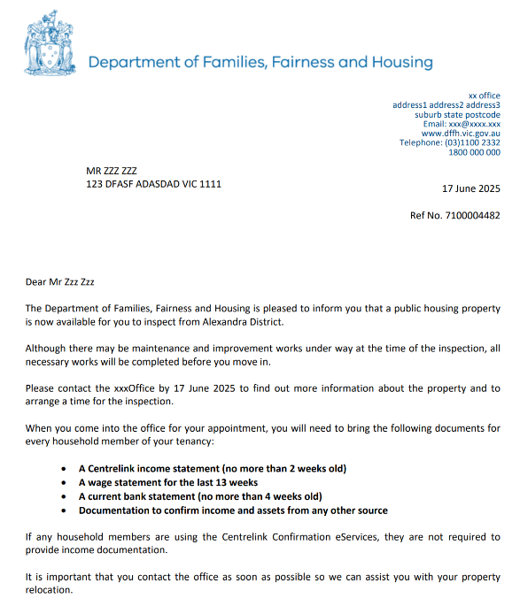
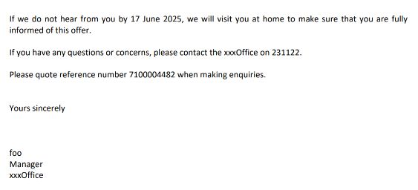
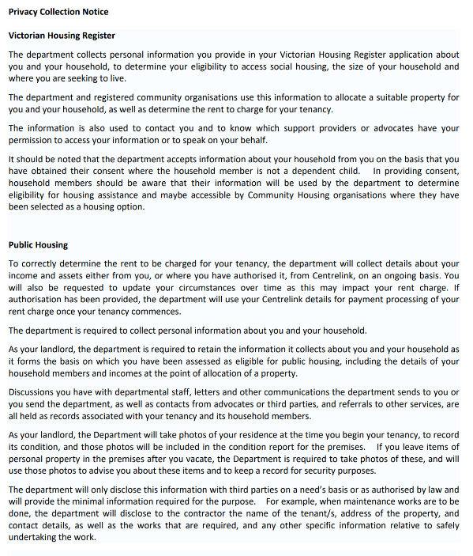

Appendix C
Information Collection notice hosted on Housing website
Arranging maintenance and repairs https://www.housing.vic.gov.au/repairs
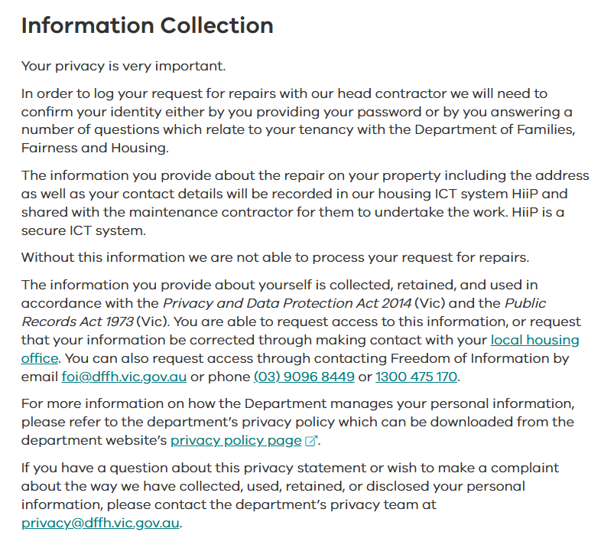

Appendix D

Confirmation email template
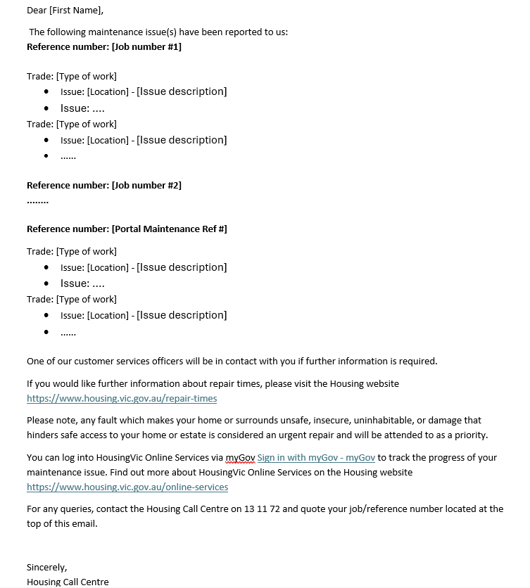

Appendix E
HousingVic Online services new screens
Homepage – new maintenance section
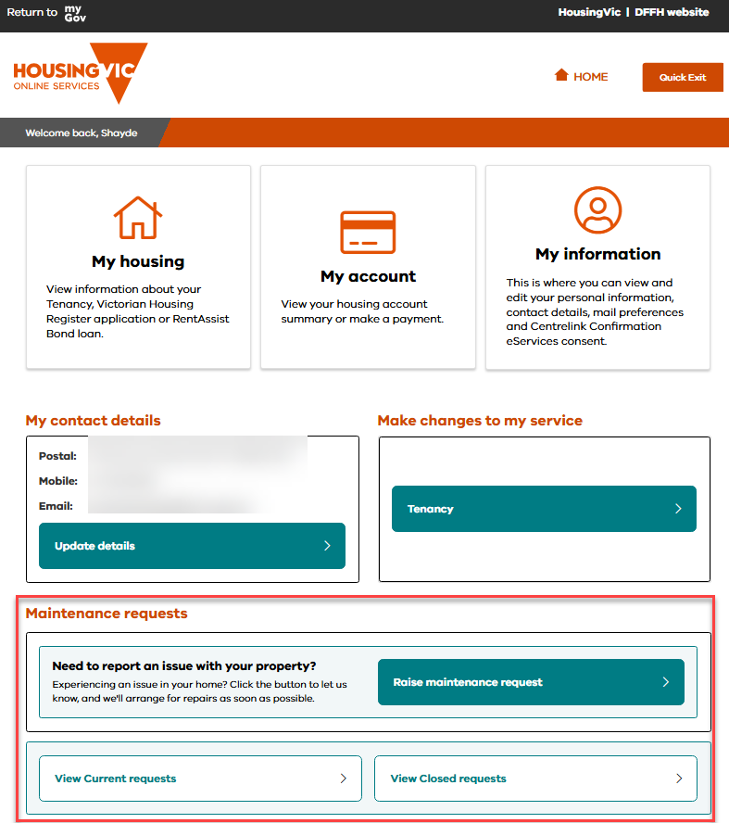

Tenancy service – new maintenance section
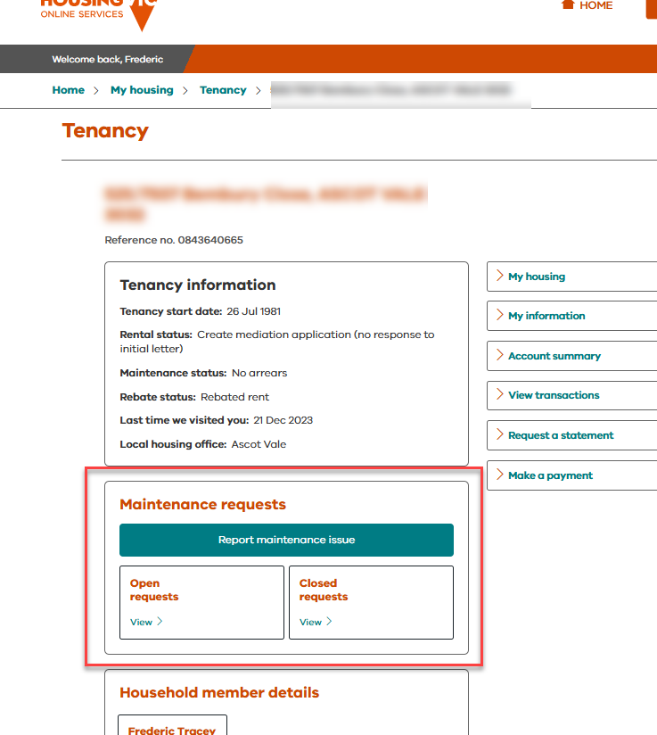

Click Report maintenance issue button – privacy and consent page
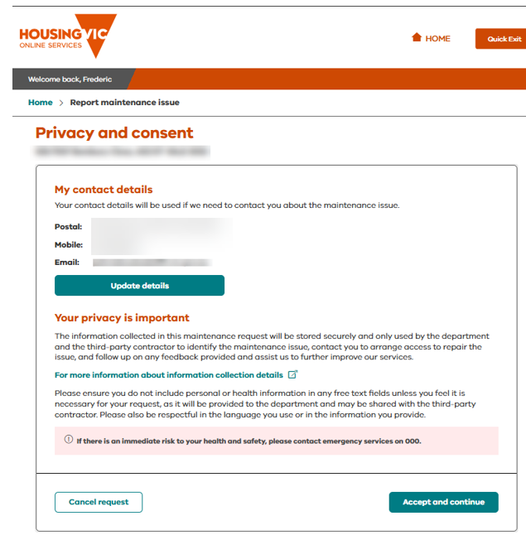

Raise maintenance request – first screen
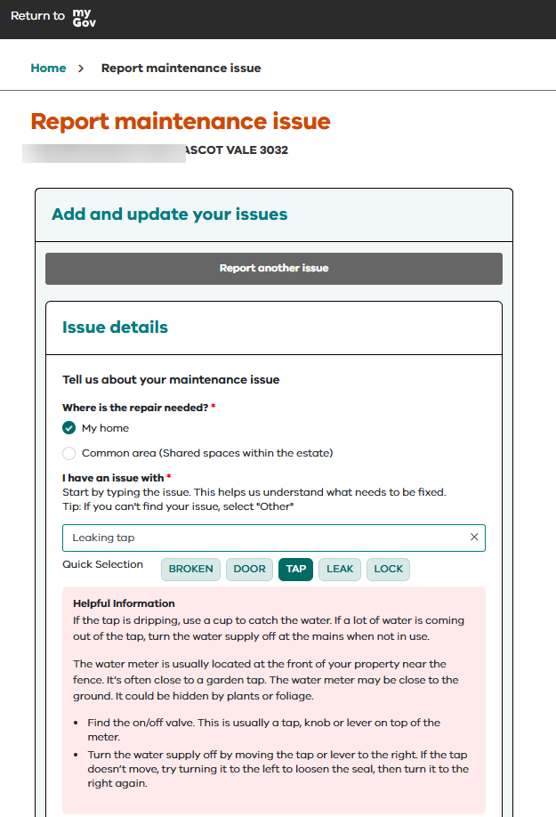
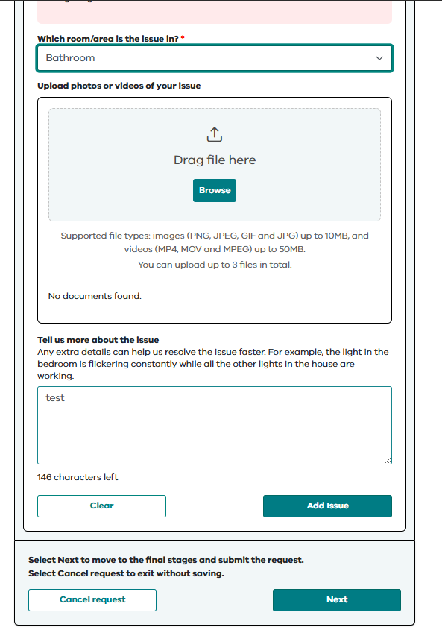

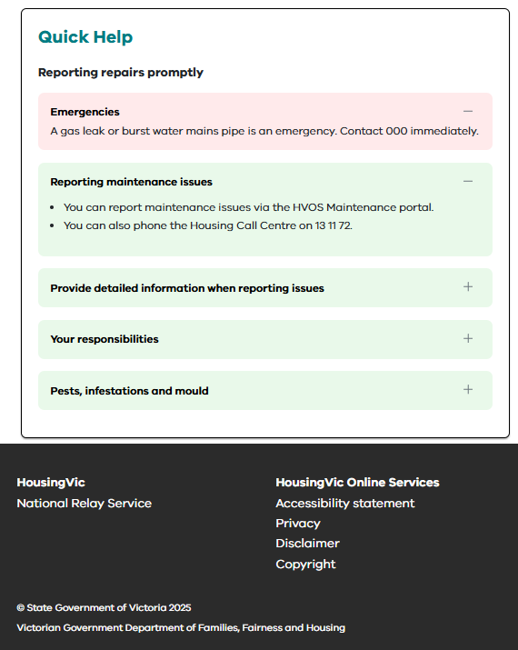

Click Next – Raise maintenance second screen
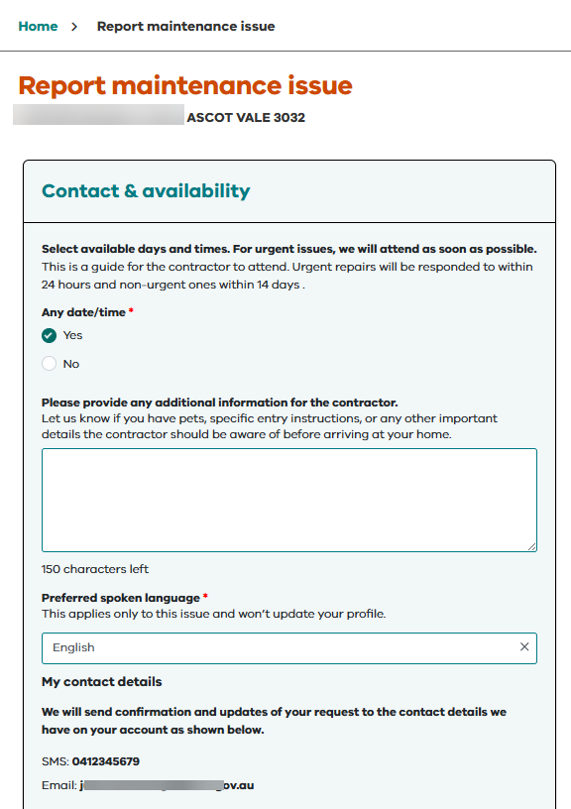
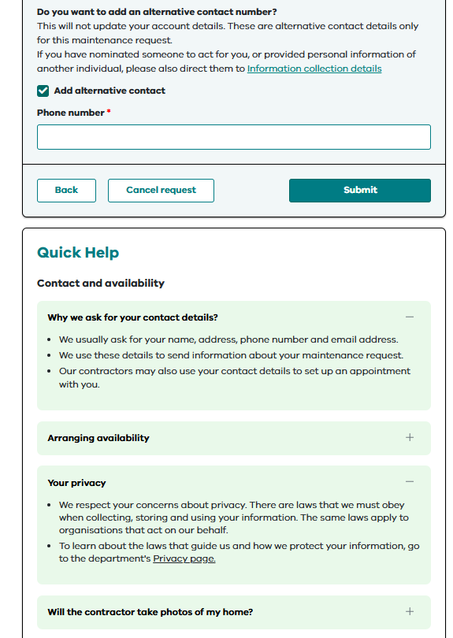
Click Submit – confirmation pop up
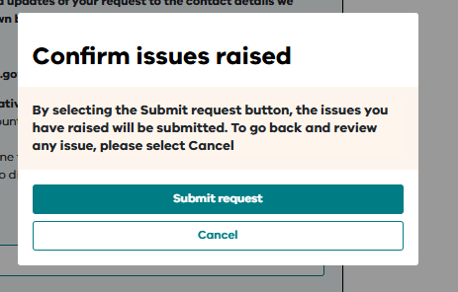

Click Submit request – confirmation message
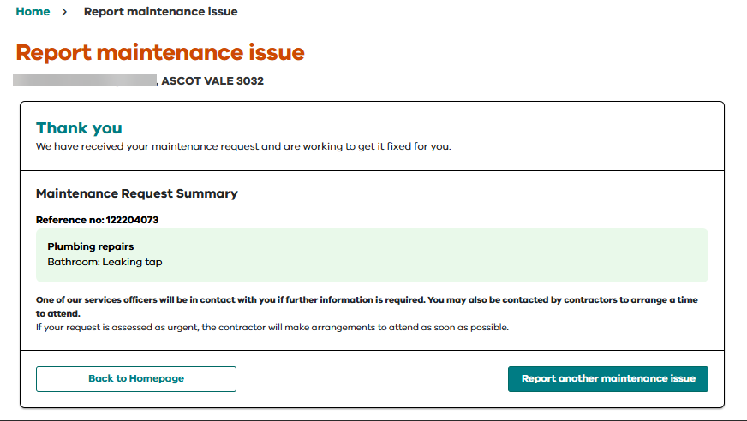

Click Back to Homepage – View current requests
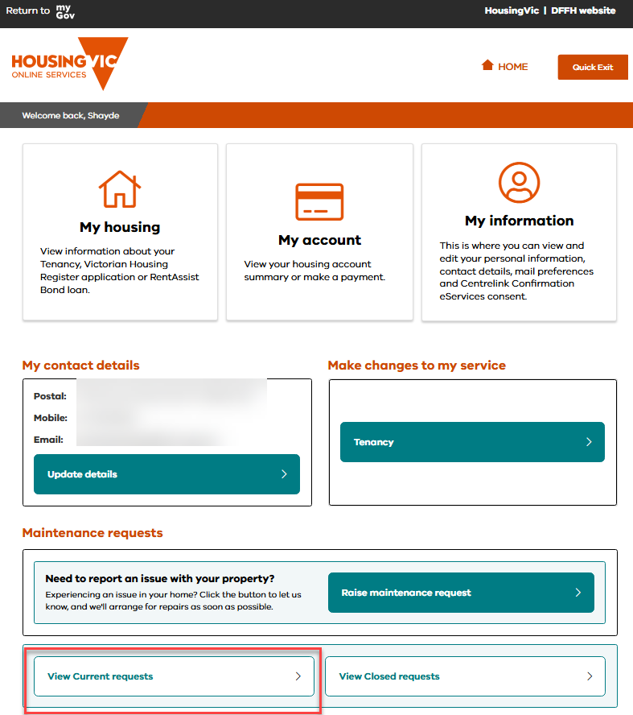

View Open requests
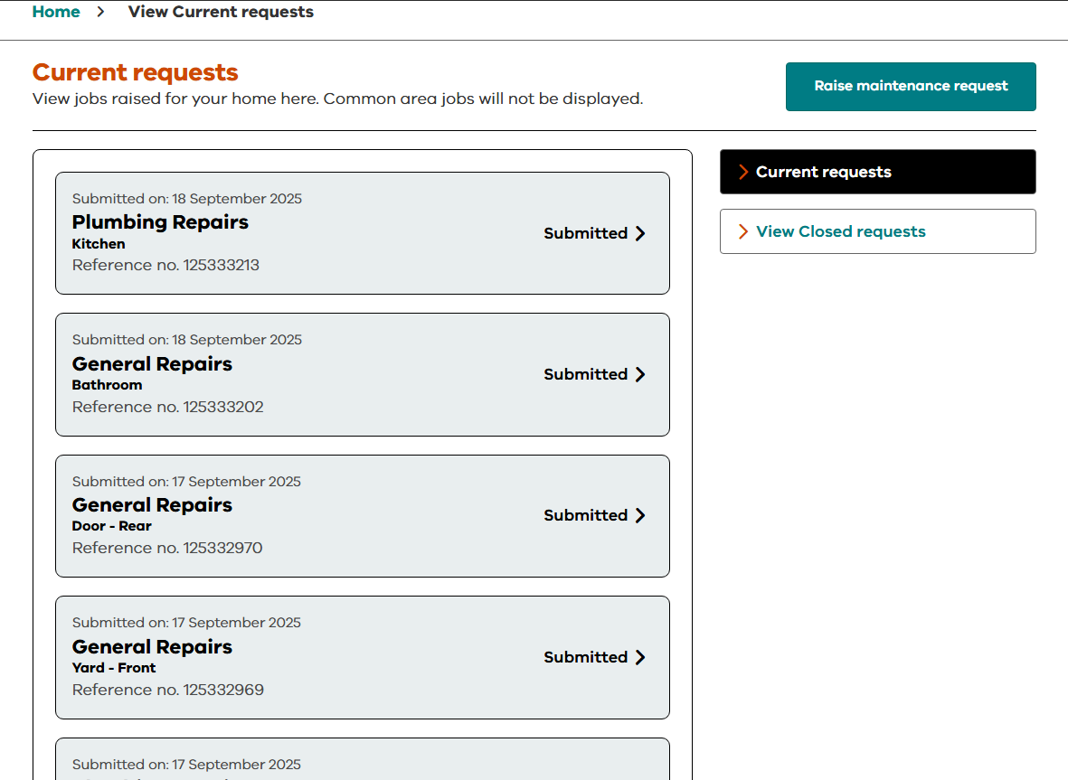

Click on first record
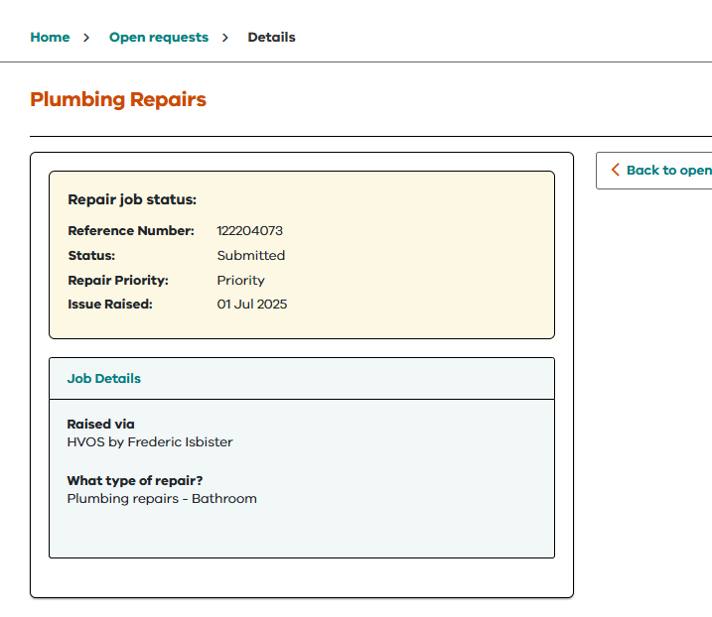

Closed requests view
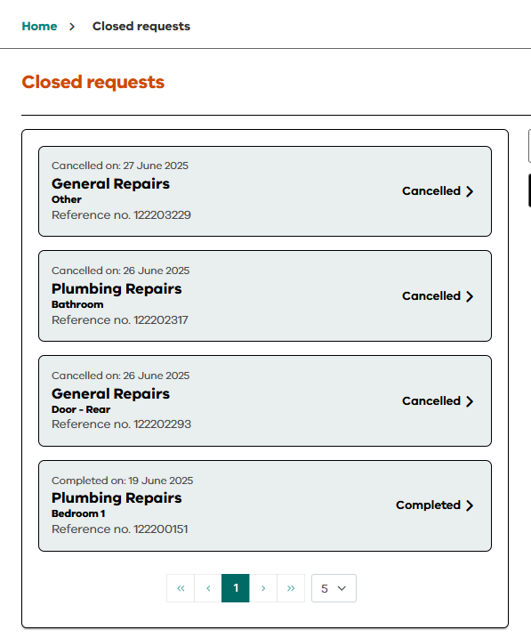
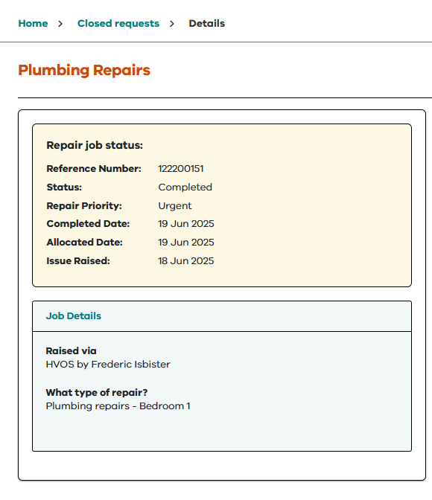

Appendix F - Records management review

Appendix G – Penetration testing
To receive this document in another format, please email the Information Sharing and Privacy Team <privacy@dffh.vic.gov.au>.
Authorised and published by the Victorian Government, 1 Treasury Place, Melbourne.
© State of Victoria, Australia, Department of Families, Fairness and Housing, July 2025.
Available at Your information on the Housing.Vic website https://www.housing.vic.gov.au/your-information

The term ‘project’ is used broadly. It is intended to cover the full range of activities and initiatives that may have privacy implications, such as a business function, new legislation or policies, an information sharing initiative, a service, an idea, new systems or applications for storing or accessing personal and/or health information.
Note that sensitive information only relates to “personal information” not “health information”.
Reference, the department’s Risk management policy and framework

