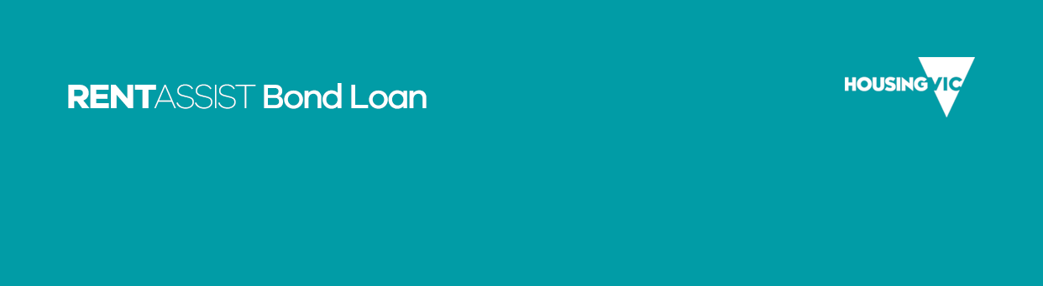

Additional bond loan applicants
(for use with the Application for a bond loan)

Use black or blue pen, use CAPITAL letters and mark boxes with an X.

Documents we need with this application
Listed below are documents that you and everyone who will live with you may need to give us to confirm your general eligibility for a bond loan.
 As you fill in the form, you will see a symbol of a piece of paper with a paperclip. It is there to tell you what other documents you may need to give us in some situations.

OFFICE USE ONLY
Date received
Received by
Date registered
Bond reference number
Name of bond agency

Evidence | Yes or No
Income proof confirmed and attached
ID proof confirmed and attached
Landlord section completed

Section F – Other applicants who are applying for a bond loan
This section should be completed for other members of your household who are applying for a bond loan. Do not include details of dependants here, except where asked.

F5 About household applicant 4
In this section we will ask for information about other household members applying for bond assistance
Questions with an (*) must be answered

F5.1 Title

Title | Mark with X
Mr
Miss
Ms
Mrs
Dr
Prof
Other

F5.2 Their name (as it appears on official documents)
First name
Middle name
Family name
Previous name (if any)
(For example, name at birth, maiden name, previous married name, alias)
Preferred name
Proof of identity documents. See ‘Proof of identity’ on page 4 of the Application for RentAssist bond loan for further information.

F5.3 Date of birth
Date of birth

F5.4 Gender
Gender | Mark with X
Male
Female
Indeterminate
Intersex
Other

F5.5 Marital status
Status | Mark with X
Single
Partnered
Married

F5.6 Country of birth
Country

F5.7 What is their residency status?
Status | Mark with X
Australian citizen – Go to F5.11
Permanent resident
New Zealand resident
Sponsored migrant
Permanent protection visa
Resolution of status visa
Visa subclass (if applicable)

Visa subclass number

F5.8 When did they start living in Australia?
Date

F5.9 Are they affected by Centrelink’s two-year newly-arrived residents waiting period?
Option | Mark with X
No
Yes

If yes, tell us the expiry date

F5.10 Did they migrate to Australia under an Assurance of support?
Option | Mark with X
No
Yes
If yes, tell us the expiry date

F5.11 Aboriginal or Torres Strait Islander?
Response | Mark with X
No
Aboriginal
Torres Strait Islander
Both

F5.12 Do they have any dependent children?

Option | Mark with X
Yes
No

Number of dependants

F6 About household applicant 5

Applicant details

F6.1 Title

Title | Mark with X
Mr
Miss
Ms
Mrs
Dr
Prof
Other

F6.2 Their name (as it appears on official documents)
First name
Middle name
Family name
Previous name (if any)
(For example, name at birth, maiden name, previous married name, alias)

Preferred name

Proof of identity documents. See ‘Proof of identity’ on page 4 for further information.

F6.3 Date of birth
Date of birth

F6.4 Gender
Gender | Mark with X
Male
Female
Indeterminate
Intersex
Other

F6.5 Marital status
Status | Mark with X
Single
Partnered
Married

F6.6 Country of birth
Country

F6.7 What is their residency status?
Status | Mark with X
Australian citizen – Go to F6.11
Permanent resident
New Zealand resident
Sponsored migrant
Permanent protection visa
Resolution of status visa
Visa subclass (if applicable)

Visa subclass number

F6.8 When did they start living in Australia?
Date

F6.9 Are they affected by Centrelink’s two-year newly-arrived residents waiting period?
Option | Mark with X
No
Yes

If yes, tell us the expiry date

F6.10 Did they migrate to Australia under an Assurance of support?
Option | Mark with X
No
Yes

If yes, tell us the expiry date

F6.11 Aboriginal or Torres Strait Islander?
Response | Mark with X
No
Aboriginal
Torres Strait Islander
Both

F6.12 Do they have any dependent children?

Option | Mark with X
Yes
No

Number of dependants

F7 Income and Assets of applicant 4

F7.1 Please select the income types they are receiving
Option | Mark with X
Centrelink Payments
Department of Veterans’ Affairs (DVA) payments
Self employed
Paying job
None
Other
If other please advise

F7.2 Please provide Centrelink Reference Number (CRN) Number
CRN

F7.3 Do you consent to income confirmation?
Option | Mark with X
No Go to F7.4
Yes Sign the Consent to use CCeS in Section I, and go to F7.5

 Proof of income documents. See ‘Proof of income’ on page 4 of the application for RentAssist bond loan.

F7.4 Assets

What is an asset?
An asset is something you own that can be turned into money — like shares, businesses, mobile homes and any cash you have in the bank.
If they are expecting to receive a payout from an organisation like WorkSafe or the Transport Accident Commission (TAC), please add it here.
Asset type | Value | Can the asset be cashed in or sold?  Write ‘Yes’ or ‘No’
 | $
 | $
 | $
 | $
 | $
 | $

You will need to attach a document confirming ownership/existence of this asset.. See proof of assets on page 4 on the Application for RentAssist bond loan for further information.

F7.5 Do they own or part-own any real estate?
Option | Mark with X
No
Yes

Property address
Suburb or town
State
Postcode
Real estate or Land value $

Are they able to live in the property (mentioned above) permanently?
Option | Mark with X
No
Yes
You will need to attach one or more of the following:
            - Letter from approved valuer or solicitor stating the property’s market value and your equity in it.
            - If the property is part owned, we need information about your share
            - If the property is held in trust, we need a letter from the executor of the estate
Attach a document that details your interest in the property and why you are unable to occupy it

Can this real estate or land be sold?
Option | Mark with X
No
Yes

Is the property for sale?
Option | Mark with X
No
Yes

You will need to attach a document from the real estate agent confirming this

If the answer is no to any of the questions above, tell us why

If the property subject to a dispute or an application for settlement in the Family Court?
Option | Mark with X
No
Yes
You will need to attach a document from a solicitor confirming this

Tell us the reason
If they are unable to live in the property permanently, we need documents that explain why.
- If the property is for sale, we need a document from the real estate agent confirming this.
- If there is a dispute or application for settlement, we need a document from your solicitor including details of ownership.

F7.6 What is their role in the household?
Role | Mark with X
Single
Partnered

Partner’s name

F7.7 What is their share of the rent in the property you want to rent?
Share of rent | $

F7.8 Do they have any dependent children who have not already been included on this form?
Do they have any dependent children?
Number of dependants

F8 Income and Assets of Household applicant 5

F8.1 Please select the income types they are receiving
Option | Mark with X
Centrelink Payments
Department of Veterans’ Affairs (DVA) payments
Self employed
Paying job
None
Other
If other please advise

F8.2 Please provide Centrelink Reference Number (CRN) Number
CRN

F8.3 Do they consent to income confirmation?
Option | Mark with X
No Go to F8.4
Yes Sign the Consent to use CCeS in Section I, and go to F8.5

Proof of income documents. See ‘Proof of income’ on page 4 for further information.

F 8.4 Assets

What is an asset?
An asset is something you own that can be turned into money — like shares, businesses, mobile homes and any cash you have in the bank.
If you are expecting to receive a payout from an organisation like WorkSafe or the Transport Accident Commission (TAC), please add it here.
Asset type | Value | Can the asset be cashed in or sold?  Write ‘Yes’ or ‘No’
 | $
 | $
 | $
 | $
 | $
 | $

You will need to attach a document confirming ownership/existence of this asset.. See proof of assets on page 4 of the Application for RentAssist bond loan for further information.

F8.5 Do they own or part-own any real estate?
Option | Mark with X
No
Yes

Property address
Suburb or town
State
Postcode
Real estate or Land value $

Are they able to live in the property (mentioned above) permanently?
Option | Mark with X
No
Yes
You will need to attach one or more of the following:
            - Letter from approved valuer or solicitor stating the property’s market value and your equity in it.
            - If the property is part owned, we need information about your share
            - If the property is held in trust, we need a letter from the executor of the estate
Attach a document that details your interest in the property and why you are unable to occupy it

Can this real estate or land be sold?
Option | Mark with X
No
Yes

Is the property for sale?
Option | Mark with X
No
Yes

You will need to attach a document from the real estate agent confirming this

If the answer is no to any of the questions above, tell us why

If the property subject to a dispute or an application for settlement in the Family Court?
Option | Mark with X
No
Yes
You will need to attach a document from a solicitor confirming this

Tell us the reason
- If you are unable to live in the property permanently, we need documents that explain why.
- If the property is for sale, we need a document from the real estate agent confirming this.
- If there is a dispute or application for settlement, we need a document from your solicitor including details of ownership.

F8.6 What is their role in the household?
Role | Mark with X
Single
Partnered

Partner’s name

F8.7 What is their share of the rent in the property you want to rent?
Share of rent | $

F8.8 Do they have any dependent children who have not already been included on this form?
Do they have any dependent children?
Number of dependants

Section G – Current or previous assistance from the Department of Families, Fairness and Housing

Social housing

G1 Does anyone included in this application have a current application on the Victorian Housing Register?
Response | Mark with X | Instructions
Yes |  | Go to G2
No |  | Go to G4

G2 Do you wish to change the postal address for the application on the Victorian Housing Register?
Response | Mark with X | Instructions
Yes |  | Go to G3
No |  | Go to G4

G3 Current details of the application on the Victorian Housing Register
Names of applicants
Service ID

G4 Has anyone included in this bond application received a bond loan from the department before?
Response | Mark with X | Instructions
Yes |  | Go to G5
No |  | Go to Section H

G5 Previous bond loan application

Primary applicant
Full name
Property address
Suburb or town
State
Postcode
When did they apply?

Has this loan been repaid?
Response | Mark with X | Instructions
Yes |  | Go to Section H
No |  | Tell us why in the next table

If no, tell us why:

Section H Statutory declaration to be signed by all applicants

Consent to be signed by all applicants
Before checking the box below, please read the following text:
A person who wilfully provides false information to the Department of Families, Fairness and Housing in order to obtain a bond loan may be liable for penalties under Section 40 of the Housing Act 1983 (VIC). Furthermore, any person or persons making a false declaration are liable to the penalties of perjury under the Evidence (Miscellaneous Provisions) Act 1958 (VIC) which may include imprisonment.

Household applicant 4
Full name
Of (current address)
Suburb or town
State
Postcode

Household applicant 5
Full name
Of (current address)
Suburb or town
State
Postcode

To the Department of Families, Fairness and Housing, 50 Lonsdale Street, Melbourne 3000:
- I, ACKNOWLEDGE that the bond money paid on my behalf to the estate agent or landlord is a loan advanced by the Director of Housing to me.
- I, ACKNOWLEDGE that all applicants are jointly, individually or separately liable for any outstanding bond loan amount. This means that each applicant and all applicants together are liable for the whole bond debt as per the original bond loan agreement. If any part of the bond is legally withheld by the estate agent or landlord, the bond debt is equally divided amongst the household members. Before receiving a further bond loan, I may be required to sign an agreement to repay the remaining bond loan amount allocated to the other household members.
- I, AUTHORISE the Department of Families, Fairness and Housing to issue a voucher payable to the Residential Tenancies Bond Authority, and undertake to provide this voucher to the estate agent or landlord together with the covering letter and bond lodgement form given to me by the Department of Families, Fairness and Housing.
- I, AGREE
- to repay the loan immediately to the Department of Families, Fairness and Housing if the bond money is returned to me during or after my tenancy
- to return to the Department of Families, Fairness and Housing the voucher for the bond money if the tenancy of the rented premises does not proceed, and
- to participate in any legal proceedings for the recovery of the bond money.
- I, ACKNOWLEDGE that I have understood the instructions and information given in this application.
- I, DECLARE that to the best of my knowledge, all the information in this application for a bond loan has been provided, and that the information I have provided is true and correct.

In Victoria and is declared by:

Print full name of Household applicant 4
Signature of Household applicant 4 | (Please sign by hand)

Print full name of Household applicant 5
Signature of Household applicant 5 | (Please sign by hand)

Witnessed before me
The authorised witness must print their name, address and title under section 107A of the Evidence (Miscellaneous Provisions) Act 1958 (VIC) (as of 1 January 2010), (previously the Evidence Act 1958 (VIC).
They may include a Justice of the Peace, police officer, court registrar, bank manager, medical practitioner, dentist or housing services officer.

Full name
Signature | (Please sign by hand)
Address
State
Postcode
Authorised title
Date
At
in Victoria

Section I – Centrelink Confirmation eServices (CCeS)
If you or any household member 18 years or over wish to use Centrelink Confirmation eServices (CCeS) to tell us about your income and assets, then please read the following information and sign the consent form.
CCeS is an online service that allows us to obtain information directly from Centrelink.
We recommend that you use CCeS if you are a Centrelink customer as we periodically require up-to-date information about your income and assets to confirm your eligibility for housing services.
CCeS has strict privacy and security standards. We must have your consent before we can obtain information about you from Centrelink.
You and your household members can provide consent by signing the Consent to use CCeS and marking the Income confirmation box with an X.
Once you have signed the consent form and marked ‘Income confirmation’ with an X, we can use CCeS to obtain information about your income and assets directly from Centrelink. This means you will not need to tell us about your income or assets (apart from lump sum payments). This will make it easier for you and quicker for us to assess your eligibility for housing services.
More information about CCeS is available on Centrelink’s website <https://www.humanservices.gov.au/individuals/services/centrelink/centrelink-confirmation-eservices>.

Consent to use Centrelink Confirmation eServices
I/we authorise the Australian Government Department of Human Services (Centrelink) to provide the Victorian Department of Families, Fairness and Housing (the department) with the results of the enquiries I/we have indicated below in order to enable the department to determine if I/we qualify for one or more of its housing services.
I/we understand that the information provided by Centrelink to the department may contain the following:
- Income confirmation – personal information such as (but not limited to)
        - current or historical details of Centrelink payments received
        - dependants
        - marital or partnered status
        - Centrelink deductions
        - income from sources other than Centrelink
        - assets.
I/we authorise the department to use Centrelink Confirmation eServices to perform a Centrelink enquiry of my/our Centrelink income, asset and payment details.
I/we understand this consent, once signed, remains valid while I am/we are a customer/s of the department unless I/we revoke it by contacting the department or Centrelink.
I/we understand that if I/we withdraw my/our consent or do not alternatively provide proof of my/our circumstances or details, I/we may not be eligible for the service provided by the department.

Household applicant 4
Full name
Date of birth
Address
Suburb or town
State
Postcode
Centrelink Reference Number (CRN)
Income confirmation (Mark with X)
Signature | (Please sign by hand)
Date

Household applicant 5
Full name
Date of birth
Address
Suburb or town
State
Postcode
Centrelink Reference Number (CRN)
Income confirmation (Mark with X)
Signature | (Please sign by hand)
Date

Checklist
Please read through this checklist to make sure that you have fully completed the form and included everything we have asked for. Mark each completed item with an X.
All documents must be dated no more than 14 days prior to the date on which you submit the application.
Item | Description | Mark with X
Section F  Other applicants | Completed details about other members of your household who are applying for this bond loan in Section F. (Do not include details of dependants here, except where asked.)
Section F: ID and residency | Provided their proof of identity and residency status if they are not born in Australia.
Section F: CCeS | Asked them, and they have completed the consent form in Section I if they wish to use Centrelink Confirmation eServices.
Section F: Income and assets | Provided details of their income and assets and the documents we ask for.
Section G  Current or previous assistance | Completed Section G about current or previous assistance that you or anyone else included in this application have received from the Department of Families, Fairness and Housing.
Section H  Statutory declaration | And all the other people applying for this bond loan, have signed the declaration in Section H.
Section H: Witness | Had the declaration signed before an authorised witness, and the authorised witness has provided their name, address, title and signature.
Section I  Centrelink Confirmation eServices | Completed and signed the consent form in Section I, and so have all the applicants who want to use Centrelink Confirmation eServices.

More information

Information privacy
The Department of Families, Fairness and Housing is committed to protecting the privacy of your personal information. Personal information is information which directly or indirectly identifies a person. We need to collect and handle your personal information in order to be able to process your application. All the information you give us will be handled in accordance with the Privacy and Data Protection Act 2014 and the Health Records Act 2001.
If you are using other department programs we may share some of your information with them to help us coordinate better services for you. We will not use your information for any other purpose other than those listed on these forms, to provide services to you, or without your consent, unless the law requires us to do so.
You can access your information through the Freedom of Information Act 1982 or through the Privacy and Data Protection Act 2014.
For information about Freedom of Information requests, call 1300 475 170 or make an online FOI request <http://www.foi.vic.gov.au/home/how+to+apply/making+a+request/making+an+online+request>.
For further information about privacy, call 1300 884 706 or email our Privacy team <privacy@dffh.vic.gov.au>.

More information
To find out about housing options, visit the Housing.vic website <http://www.housing.vic.gov.au> or contact your local housing office online <http://www.housing.vic.gov.au/contact-a-housing-office>.

To receive this publication in an accessible format email Housing Business Support <housingbusiness.support@dffh.vic.gov.au>.
Authorised and published by the Victorian Government, 1 Treasury Place, Melbourne.
© State of Victoria, Department of Families, Fairness and Housing, April 2022.
Available on Housing.vic’s Apply for a bond loan page <http://www.housing.vic.gov.au/apply-bond-loan>.

Language Link
This publication is about housing. If you have difficulty reading English, you can get help with this publication. Please contact your local office or call Language Link on (03) 9328 0799 for an interpreter.
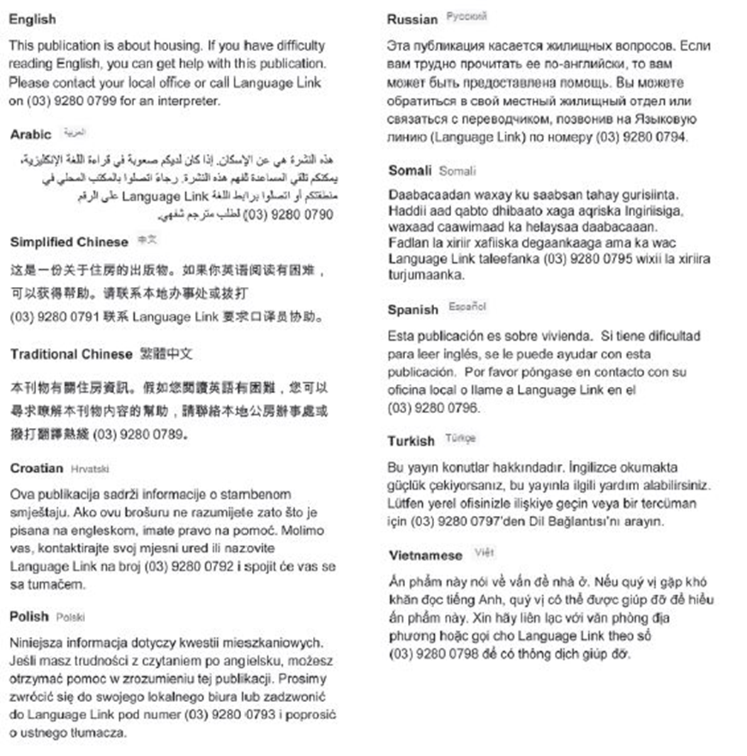
For other languages, an interpreter is available through your local office.

