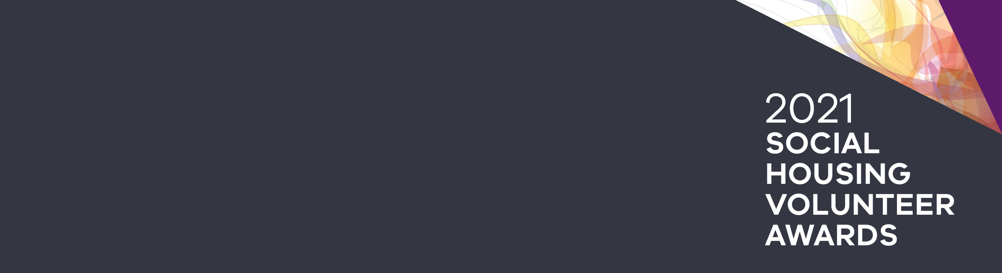
How to nominate a social housing renter
Francis Penington and Molly Hadfield Awards

Recognising community achievement
In every community, there are exceptional people who reach out, lend a hand and get involved. These are the people who go above and beyond to help others and in doing so, build a strong community spirit.
The Frances Penington and Molly Hadfield Awards publicly acknowledge an individual renter, or a group of renters, who make a positive impact in their local community.
The Department of Families, Fairness and Housing is calling for nominations for these two awards.

The Frances Penington Award

Who is making a difference in your community?
Eligibility criteria:
- individual public or community housing tenant, or a group of tenants
- who are making an outstanding voluntary contribution to their community.

The Frances Penington Award recognises an individual public or community housing renters, or a group of renters, who are making an outstanding voluntary contribution to their community.
The award honours the late Frances Penington, a Commissioner of the Housing Commission and the first woman appointed to the board of a statutory authority in Victoria. She was also a strong advocate for public housing renters, particularly for women living in housing estates.
In keeping with the memory of Frances Penington, this award recognises the achievements of role models, community builders and local heroes who have gone out of their way to help their neighbours, volunteered with a community group, or proactively found solutions to address local neighbourhood issues.

The Molly Hadfield Award

Who is making a difference for older renters in your community?
Eligibility criteria:
- individual public or community housing renter or a group of renters
- who are having a positive effect on the lives of older renters in their community.

The award honours the work of the late Mary (Molly) Hadfield who was a dedicated advocate for public housing renters. She was also a founding member of the Housing for the Aged Action Group, which started 1983.

In 2006, she was awarded the Medal of the Order of Australia for services to the community across the areas of aged care, community health and youth. In the same year she was inducted into the Victorian Honour Roll of Women.

How to make a nomination
If you know someone or a group of people whose outstanding contribution should be recognised, please complete the nomination form and return it by 1 October 2021. The nomination form is available on the housing website, visit the Social Housing Volunteers Awards page on the Housing website <http://housing.vic.gov.au/social-housing-volunteer-awards>.
All nominees for the awards will receive a certificate of recognition.
The Minster for Housing, Hon Richard Wynne will announce recipients of the Frances Penington Award and Molly Hadfield Award at a special ceremony on Thursday 9 December 2021. The department will notify and invite nominees to this event.
Please ensure you complete all parts of the nomination form, including the declaration and signature of the person or group being nominated.

More information
For further information about the Frances Penington Award or the Molly Hadfield Award
call us on (03) 8633 4357/ 0439 209 122 or visit the Social Housing Volunteers Awards page on the Housing website <http://housing.vic.gov.au/social-housing-volunteer-awards>.

To receive this publication in an accessible format, email Housing Business Support <housingbusiness.support@dffh.vic.gov.au>.
Authorised and published by the Victorian Government, 1 Treasury Place, Melbourne.
© State of Victoria, Department of Families, Fairness and Housing, June 2021.
Available on the Social Housing Volunteers Awards page on the Housing website <http://housing.vic.gov.au/social-housing-volunteer-awards>.

